# Model

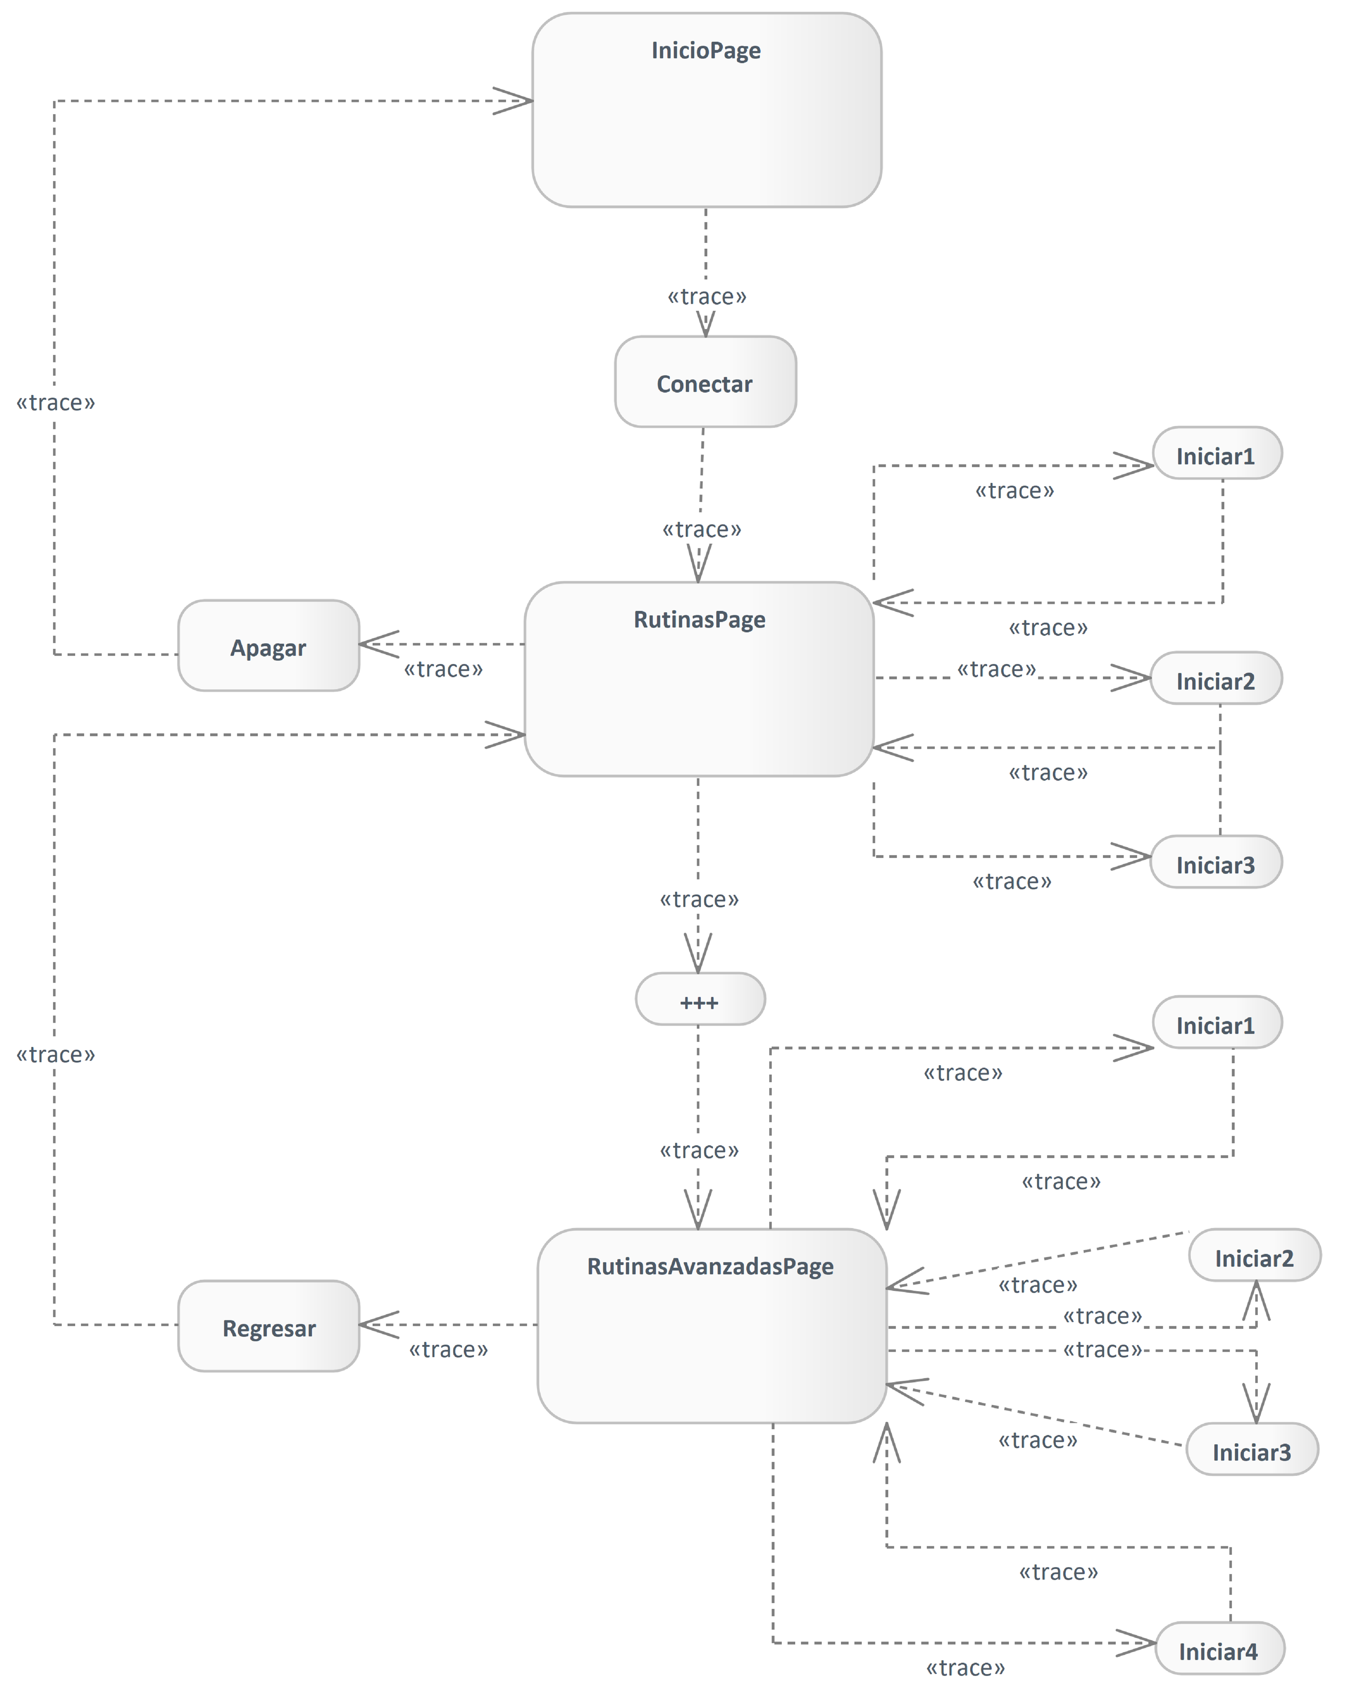

1. Activity

## Clase y dominio

Package in package 'Model'

Clase y dominio

Version 1.0 Phase 1.0 Proposed

carpi created on 25/4/2025. Last modified 28/4/2025

### Dominio diagram

Class diagram in package 'Clase y dominio'

Dominio

Version 1.0

carpi created on 25/4/2025. Last modified 28/4/2025

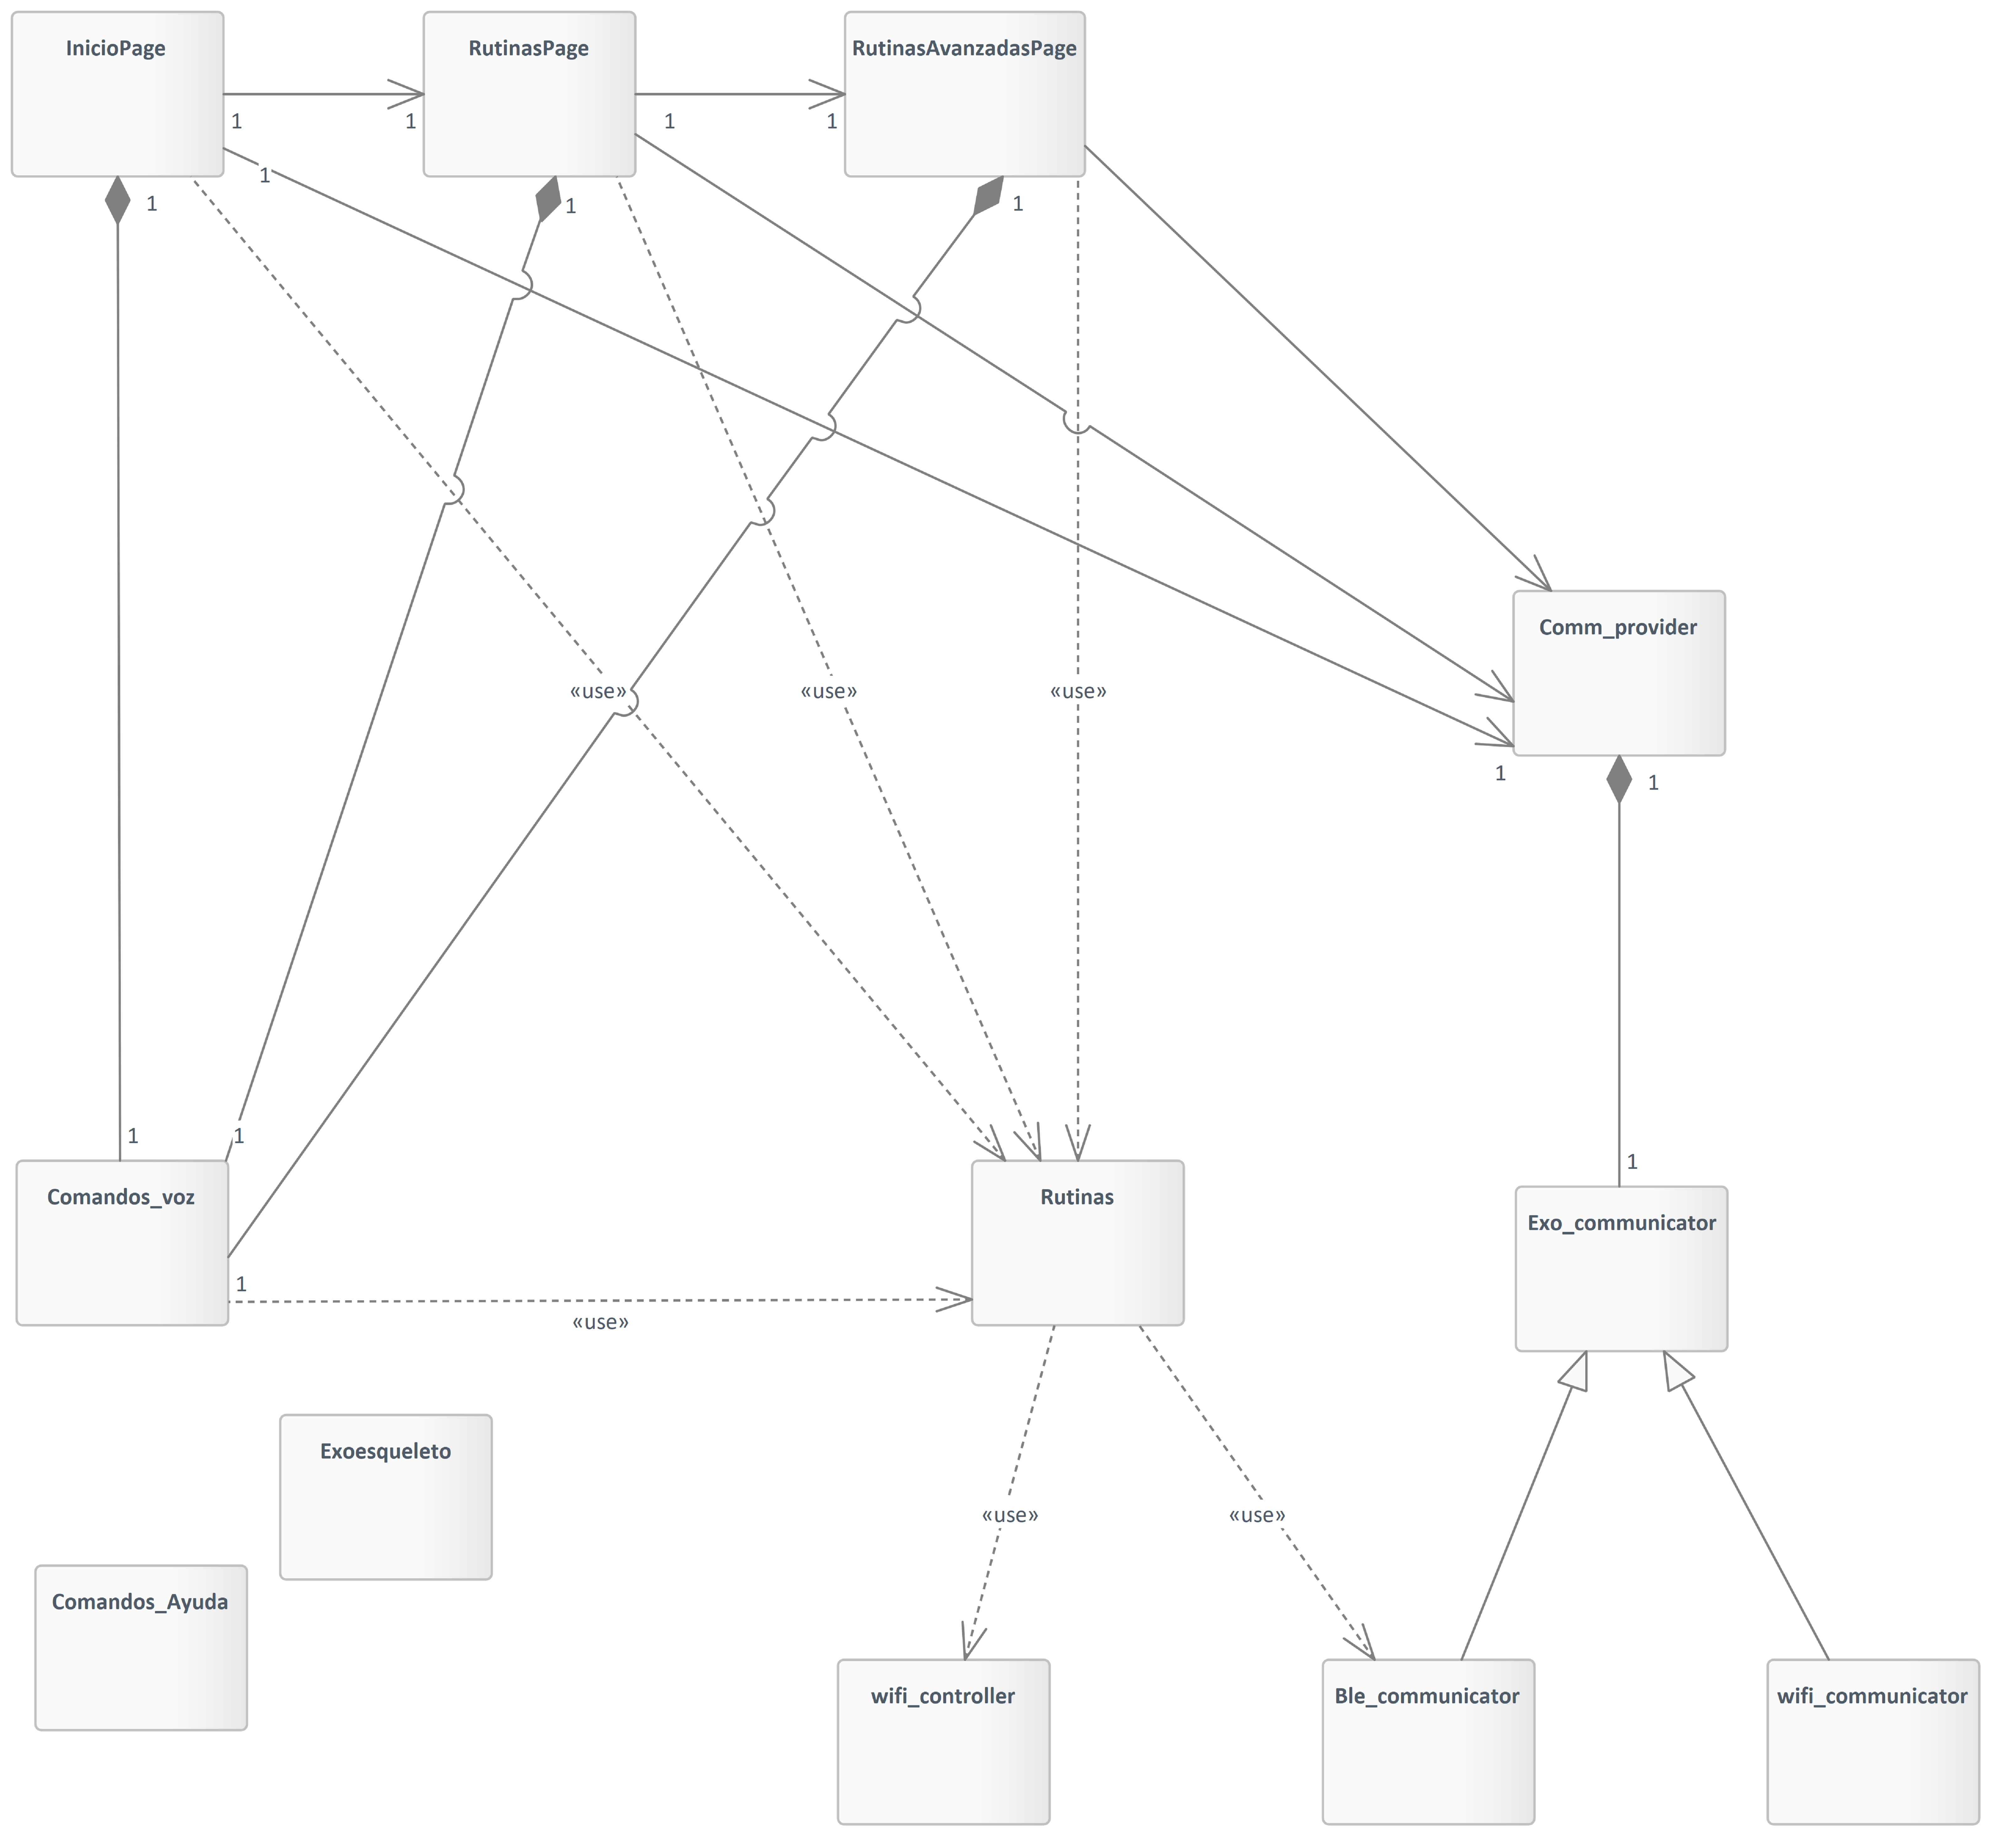

1. Dominio

### Class

Package in package 'Clase y dominio'

Class

Version 1.0 Phase 1.0 Proposed

carpi created on 25/4/2025. Last modified 25/4/2025

#### Class diagram

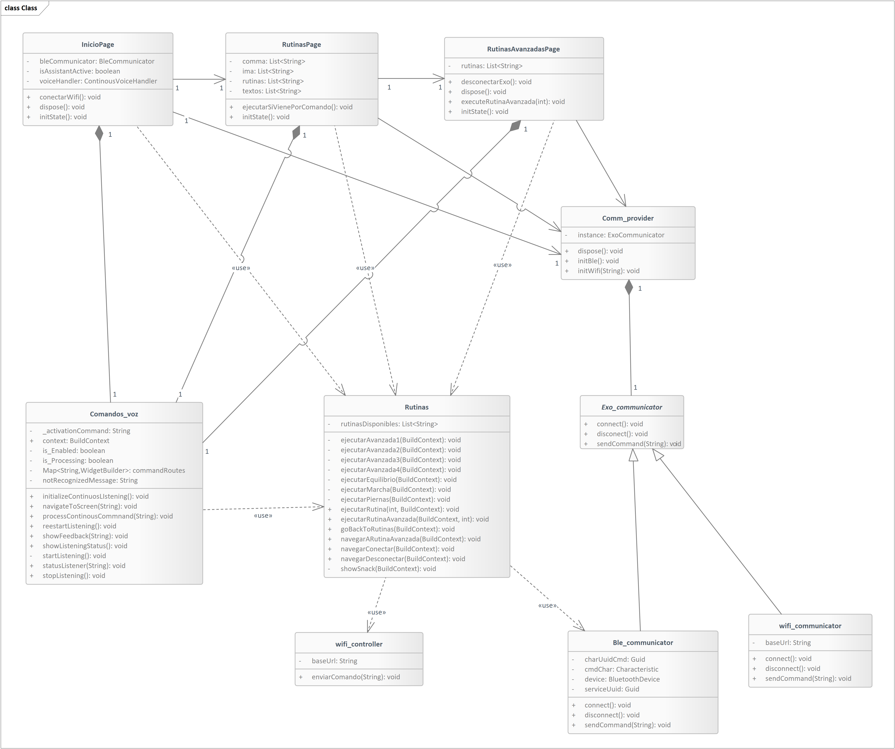

Class

Version 1.0

carpi created on 25/4/2025. Last modified 28/4/2025

1. Class

#### Ble_communicator

Class in package 'Class'

Ble_communicator

Version 1.0 Phase 1.0 Proposed

carpi created on 25/4/2025. Last modified 25/4/2025

| OUTGOING STRUCTURAL RELATIONSHIPS |
| --- |
| Generalization from Ble_communicator to Exo_communicator  [ Direction is 'Source -> Destination'. ] |

| CONNECTORS |
| --- |
| Usage Source -> Destination  From: Rutinas : Class, Public  To: Ble_communicator : Class, Public |

| ATTRIBUTES |
| --- |
| charUuidCmd : Guid Private  [ Is static True. Containment is Not Specified. ] |
| cmdChar : Characteristic Private  [ Is static True. Containment is Not Specified. ] |
| device : BluetoothDevice Private  [ Is static True. Containment is Not Specified. ] |
| serviceUuid : Guid Private  [ Is static True. Containment is Not Specified. ] |

| OPERATIONS |
| --- |
| connect () : void Public  [ Is static False. Is abstract False. Is return array False. Is query False. Is synchronized False. ] |
| disconnect () : void Public  [ Is static False. Is abstract False. Is return array False. Is query False. Is synchronized False. ] |
| sendCommand (command : String ) : void Public  [ Is static False. Is abstract False. Is return array False. Is query False. Is synchronized False. ] |

#### Comandos_Ayuda

Class in package 'Class'

Comandos_Ayuda

Version 1.0 Phase 1.0 Proposed

carpi created on 25/4/2025. Last modified 25/4/2025

#### Comandos_voz

Class in package 'Class'

Comandos_voz

Version 1.0 Phase 1.0 Proposed

carpi created on 25/4/2025. Last modified 25/4/2025

| OUTGOING STRUCTURAL RELATIONSHIPS |
| --- |
| Aggregation from Comandos_voz to InicioPage  [ Direction is 'Source -> Destination'. ] |
| Aggregation from Comandos_voz to RutinasAvanzadasPage  [ Direction is 'Source -> Destination'. ] |
| Aggregation from Comandos_voz to RutinasPage  [ Direction is 'Source -> Destination'. ] |

| CONNECTORS |
| --- |
| Usage Source -> Destination  From: Comandos_voz : Class, Public  To: Rutinas : Class, Public |

| ATTRIBUTES |
| --- |
| _activationCommand : String Private  [ Is static True. Containment is Not Specified. ] |
| context : BuildContext Public  [ Is static True. Containment is Not Specified. ] |
| is_Enabled : boolean Private  [ Is static True. Containment is Not Specified. ] |
| is_Processing : boolean Private  [ Is static True. Containment is Not Specified. ] |
| Map<String,WidgetBuilder> : commandRoutes Private  [ Is static True. Containment is Not Specified. ] |
| notRecognizedMessage : String Private  [ Is static True. Containment is Not Specified. ] |

| OPERATIONS |
| --- |
| initializeContinuosLIstening () : void Public  [ Is static False. Is abstract False. Is return array False. Is query False. Is synchronized False. ] |
| navigateToScreen (cmd : String ) : void Public  [ Is static False. Is abstract False. Is return array False. Is query False. Is synchronized False. ] |
| processContinousCommnand (status : String ) : void Public  [ Is static False. Is abstract False. Is return array False. Is query False. Is synchronized False. ] |
| reestartListening () : void Public  [ Is static False. Is abstract False. Is return array False. Is query False. Is synchronized False. ] |
| showFeedback (text : String ) : void Public  [ Is static False. Is abstract False. Is return array False. Is query False. Is synchronized False. ] |
| showListeningStatus () : void Public  [ Is static False. Is abstract False. Is return array False. Is query False. Is synchronized False. ] |
| startListening () : void Private  [ Is static False. Is abstract False. Is return array False. Is query False. Is synchronized False. ] |
| statusListener (status : String ) : void Public  [ Is static False. Is abstract False. Is return array False. Is query False. Is synchronized False. ] |
| stopListening () : void Public  [ Is static False. Is abstract False. Is return array False. Is query False. Is synchronized False. ] |

#### Comm_provider

Class in package 'Class'

Comm_provider

Version 1.0 Phase 1.0 Proposed

carpi created on 25/4/2025. Last modified 25/4/2025

| INCOMING STRUCTURAL RELATIONSHIPS |
| --- |
| Aggregation from Exo_communicator to Comm_provider  [ Direction is 'Source -> Destination'. ] |

| ATTRIBUTES |
| --- |
| instance : ExoCommunicator Private  [ Is static True. Containment is Not Specified. ] |

| ASSOCIATIONS | |
| --- | --- |
| Association (direction: Source -> Destination) | |
| Source: Public (Class) RutinasAvanzadasPage | Target: Public (Class) Comm_provider |
| Association (direction: Source -> Destination) | |
| Source: Public (Class) InicioPage  Cardinality: [1] | Target: Public (Class) Comm_provider  Cardinality: [1] |
| Association (direction: Source -> Destination) | |
| Source: Public (Class) RutinasPage | Target: Public (Class) Comm_provider |

| OPERATIONS |
| --- |
| dispose () : void Public  [ Is static False. Is abstract False. Is return array False. Is query False. Is synchronized False. ] |
| initBle () : void Public  [ Is static False. Is abstract False. Is return array False. Is query False. Is synchronized False. ] |
| initWifi (ip : String ) : void Public  [ Is static False. Is abstract False. Is return array False. Is query False. Is synchronized False. ] |

#### Exo_communicator

Class in package 'Class'

Exo_communicator

Version 1.0 Phase 1.0 Proposed

carpi created on 25/4/2025. Last modified 28/4/2025

| OUTGOING STRUCTURAL RELATIONSHIPS |
| --- |
| Aggregation from Exo_communicator to Comm_provider  [ Direction is 'Source -> Destination'. ] |

| INCOMING STRUCTURAL RELATIONSHIPS |
| --- |
| Generalization from wifi_communicator to Exo_communicator  [ Direction is 'Source -> Destination'. ] |
| Generalization from Ble_communicator to Exo_communicator  [ Direction is 'Source -> Destination'. ] |

| OPERATIONS |
| --- |
| connect () : void Public  [ Is static False. Is abstract False. Is return array False. Is query False. Is synchronized False. ] |
| disconect () : void Public  [ Is static False. Is abstract False. Is return array False. Is query False. Is synchronized False. ] |
| sendCommand (command : String ) : void Public  [ Is static False. Is abstract False. Is return array False. Is query False. Is synchronized False. ] |

#### InicioPage

Class in package 'Class'

InicioPage

Version 1.0 Phase 1.0 Proposed

carpi created on 25/4/2025. Last modified 25/4/2025

| INCOMING STRUCTURAL RELATIONSHIPS |
| --- |
| Aggregation from Comandos_voz to InicioPage  [ Direction is 'Source -> Destination'. ] |

| CONNECTORS |
| --- |
| Usage Source -> Destination  From: InicioPage : Class, Public  To: Rutinas : Class, Public |

| ATTRIBUTES |
| --- |
| bleCommunicator : BleCommunicator Private  [ Is static True. Containment is Not Specified. ] |
| isAssistantActive : boolean Private  [ Is static True. Containment is Not Specified. ] |
| voiceHandler : ContinousVoiceHandler Private  [ Is static True. Containment is Not Specified. ] |

| ASSOCIATIONS | |
| --- | --- |
| Association (direction: Source -> Destination) | |
| Source: Public (Class) InicioPage  Cardinality: [1] | Target: Public (Class) RutinasPage  Cardinality: [1] |
| Association (direction: Source -> Destination) | |
| Source: Public (Class) InicioPage  Cardinality: [1] | Target: Public (Class) Comm_provider  Cardinality: [1] |

| OPERATIONS |
| --- |
| conectarWifi () : void Public  [ Is static False. Is abstract False. Is return array False. Is query False. Is synchronized False. ] |
| dispose () : void Public  [ Is static False. Is abstract False. Is return array False. Is query False. Is synchronized False. ] |
| initState () : void Public  [ Is static False. Is abstract False. Is return array False. Is query False. Is synchronized False. ] |

#### Rutinas

Class in package 'Class'

Rutinas

Version 1.0 Phase 1.0 Proposed

carpi created on 25/4/2025. Last modified 25/4/2025

| CONNECTORS |
| --- |
| Usage Source -> Destination  From: Rutinas : Class, Public  To: wifi_controller : Class, Public |
| Usage Source -> Destination  From: Rutinas : Class, Public  To: Ble_communicator : Class, Public |
| Usage Source -> Destination  From: Comandos_voz : Class, Public  To: Rutinas : Class, Public |
| Usage Source -> Destination  From: RutinasAvanzadasPage : Class, Public  To: Rutinas : Class, Public |
| Usage Source -> Destination  From: RutinasPage : Class, Public  To: Rutinas : Class, Public |
| Usage Source -> Destination  From: InicioPage : Class, Public  To: Rutinas : Class, Public |

| ATTRIBUTES |
| --- |
| rutinasDisponibles : List<String> Private  [ Is static True. Containment is Not Specified. ] |

| OPERATIONS |
| --- |
| ejecutarAvanzada1 (context : BuildContext ) : void Private  [ Is static False. Is abstract False. Is return array False. Is query False. Is synchronized False. ] |
| ejecutarAvanzada2 (context : BuildContext ) : void Private  [ Is static False. Is abstract False. Is return array False. Is query False. Is synchronized False. ] |
| ejecutarAvanzada3 (context : BuildContext ) : void Private  [ Is static False. Is abstract False. Is return array False. Is query False. Is synchronized False. ] |
| ejecutarAvanzada4 (context : BuildContext ) : void Private  [ Is static False. Is abstract False. Is return array False. Is query False. Is synchronized False. ] |
| ejecutarEquilibrio (context : BuildContext ) : void Private  [ Is static False. Is abstract False. Is return array False. Is query False. Is synchronized False. ] |
| ejecutarMarcha (context : BuildContext ) : void Private  [ Is static False. Is abstract False. Is return array False. Is query False. Is synchronized False. ] |
| ejecutarPiernas (context : BuildContext ) : void Private  [ Is static False. Is abstract False. Is return array False. Is query False. Is synchronized False. ] |
| ejecutarRutina (index : int , context : BuildContext ) : void Public  [ Is static False. Is abstract False. Is return array False. Is query False. Is synchronized False. ] |
| ejecutarRutinaAvanzada (context : BuildContext , index : int ) : void Public  [ Is static False. Is abstract False. Is return array False. Is query False. Is synchronized False. ] |
| goBackToRutinas (context : BuildContext ) : void Public  [ Is static False. Is abstract False. Is return array False. Is query False. Is synchronized False. ] |
| navegarARutinaAvanzada (context : BuildContext ) : void Public  [ Is static False. Is abstract False. Is return array False. Is query False. Is synchronized False. ] |
| navegarConectar (context : BuildContext ) : void Public  [ Is static False. Is abstract False. Is return array False. Is query False. Is synchronized False. ] |
| navegarDesconectar (context : BuildContext ) : void Public  [ Is static False. Is abstract False. Is return array False. Is query False. Is synchronized False. ] |
| showSnack (context : BuildContext ) : void Private  [ Is static False. Is abstract False. Is return array False. Is query False. Is synchronized False. ] |

#### RutinasAvanzadasPage

Class in package 'Class'

RutinasAvanzadasPage

Version 1.0 Phase 1.0 Proposed

carpi created on 25/4/2025. Last modified 25/4/2025

| INCOMING STRUCTURAL RELATIONSHIPS |
| --- |
| Aggregation from Comandos_voz to RutinasAvanzadasPage  [ Direction is 'Source -> Destination'. ] |

| CONNECTORS |
| --- |
| Usage Source -> Destination  From: RutinasAvanzadasPage : Class, Public  To: Rutinas : Class, Public |

| ATTRIBUTES |
| --- |
| rutinas : List<String> Private  [ Is static True. Containment is Not Specified. ] |

| ASSOCIATIONS | |
| --- | --- |
| Association (direction: Source -> Destination) | |
| Source: Public (Class) RutinasAvanzadasPage | Target: Public (Class) Comm_provider |
| Association (direction: Source -> Destination) | |
| Source: Public (Class) RutinasPage  Cardinality: [1] | Target: Public (Class) RutinasAvanzadasPage  Cardinality: [1] |

| OPERATIONS |
| --- |
| desconectarExo () : void Public  [ Is static False. Is abstract False. Is return array False. Is query False. Is synchronized False. ] |
| dispose () : void Public  [ Is static False. Is abstract False. Is return array False. Is query False. Is synchronized False. ] |
| executeRutinaAvanzada (index : int ) : void Public  [ Is static False. Is abstract False. Is return array False. Is query False. Is synchronized False. ] |
| initState () : void Public  [ Is static False. Is abstract False. Is return array False. Is query False. Is synchronized False. ] |

#### RutinasPage

Class in package 'Class'

RutinasPage

Version 1.0 Phase 1.0 Proposed

carpi created on 25/4/2025. Last modified 25/4/2025

| INCOMING STRUCTURAL RELATIONSHIPS |
| --- |
| Aggregation from Comandos_voz to RutinasPage  [ Direction is 'Source -> Destination'. ] |

| CONNECTORS |
| --- |
| Usage Source -> Destination  From: RutinasPage : Class, Public  To: Rutinas : Class, Public |

| ATTRIBUTES |
| --- |
| comma : List<String> Private  [ Is static True. Containment is Not Specified. ] |
| ima : List<String> Private  [ Is static True. Containment is Not Specified. ] |
| rutinas : List<String> Private  [ Is static True. Containment is Not Specified. ] |
| textos : List<String> Private  [ Is static True. Containment is Not Specified. ] |

| ASSOCIATIONS | |
| --- | --- |
| Association (direction: Source -> Destination) | |
| Source: Public (Class) RutinasPage  Cardinality: [1] | Target: Public (Class) RutinasAvanzadasPage  Cardinality: [1] |
| Association (direction: Source -> Destination) | |
| Source: Public (Class) RutinasPage | Target: Public (Class) Comm_provider |
| Association (direction: Source -> Destination) | |
| Source: Public (Class) InicioPage  Cardinality: [1] | Target: Public (Class) RutinasPage  Cardinality: [1] |

| OPERATIONS |
| --- |
| ejecutarSiVienePorComando () : void Public  [ Is static False. Is abstract False. Is return array False. Is query False. Is synchronized False. ] |
| initState () : void Public  [ Is static False. Is abstract False. Is return array False. Is query False. Is synchronized False. ] |

#### wifi_communicator

Class in package 'Class'

wifi_communicator

Version 1.0 Phase 1.0 Proposed

carpi created on 25/4/2025. Last modified 25/4/2025

| OUTGOING STRUCTURAL RELATIONSHIPS |
| --- |
| Generalization from wifi_communicator to Exo_communicator  [ Direction is 'Source -> Destination'. ] |

| ATTRIBUTES |
| --- |
| baseUrl : String Private  [ Is static True. Containment is Not Specified. ] |

| OPERATIONS |
| --- |
| connect () : void Public  [ Is static False. Is abstract False. Is return array False. Is query False. Is synchronized False. ] |
| disconnect () : void Public  [ Is static False. Is abstract False. Is return array False. Is query False. Is synchronized False. ] |
| sendCommand (command : String ) : void Public  [ Is static False. Is abstract False. Is return array False. Is query False. Is synchronized False. ] |

#### wifi_controller

Class in package 'Class'

wifi_controller

Version 1.0 Phase 1.0 Proposed

carpi created on 25/4/2025. Last modified 25/4/2025

| CONNECTORS |
| --- |
| Usage Source -> Destination  From: Rutinas : Class, Public  To: wifi_controller : Class, Public |

| ATTRIBUTES |
| --- |
| baseUrl : String Private  [ Is static True. Containment is Not Specified. ] |

| OPERATIONS |
| --- |
| enviarComando (comando : String ) : void Public  [ Is static False. Is abstract False. Is return array False. Is query False. Is synchronized False. ] |

### Ble_communicator

Class in package 'Clase y dominio'

Ble_communicator

Version 1.0 Phase 1.0 Proposed

carpi created on 25/4/2025. Last modified 25/4/2025

| OUTGOING STRUCTURAL RELATIONSHIPS |
| --- |
| Generalization from Ble_communicator to Exo_communicator  [ Direction is 'Source -> Destination'. ] |

| CONNECTORS |
| --- |
| Usage Source -> Destination  From: Rutinas : Class, Public  To: Ble_communicator : Class, Public |

### Comandos_Ayuda

Class in package 'Clase y dominio'

Comandos_Ayuda

Version 1.0 Phase 1.0 Proposed

carpi created on 25/4/2025. Last modified 25/4/2025

### Comandos_voz

Class in package 'Clase y dominio'

Comandos_voz

Version 1.0 Phase 1.0 Proposed

carpi created on 25/4/2025. Last modified 25/4/2025

| OUTGOING STRUCTURAL RELATIONSHIPS |
| --- |
| Aggregation from Comandos_voz to InicioPage  [ Direction is 'Source -> Destination'. ] |
| Aggregation from Comandos_voz to RutinasPage  [ Direction is 'Source -> Destination'. ] |
| Aggregation from Comandos_voz to RutinasAvanzadasPage  [ Direction is 'Source -> Destination'. ] |

| CONNECTORS |
| --- |
| Usage Source -> Destination  From: Comandos_voz : Class, Public  To: Rutinas : Class, Public |

### Comm_provider

Class in package 'Clase y dominio'

Comm_provider

Version 1.0 Phase 1.0 Proposed

carpi created on 25/4/2025. Last modified 25/4/2025

| INCOMING STRUCTURAL RELATIONSHIPS |
| --- |
| Aggregation from Exo_communicator to Comm_provider  [ Direction is 'Source -> Destination'. ] |

| ASSOCIATIONS | |
| --- | --- |
| Association (direction: Source -> Destination) | |
| Source: Public (Class) RutinasPage | Target: Public (Class) Comm_provider |
| Association (direction: Source -> Destination) | |
| Source: Public (Class) InicioPage  Cardinality: [1] | Target: Public (Class) Comm_provider  Cardinality: [1] |
| Association (direction: Source -> Destination) | |
| Source: Public (Class) RutinasAvanzadasPage | Target: Public (Class) Comm_provider |

### Exo_communicator

Class in package 'Clase y dominio'

Exo_communicator

Version 1.0 Phase 1.0 Proposed

carpi created on 25/4/2025. Last modified 25/4/2025

| OUTGOING STRUCTURAL RELATIONSHIPS |
| --- |
| Aggregation from Exo_communicator to Comm_provider  [ Direction is 'Source -> Destination'. ] |

| INCOMING STRUCTURAL RELATIONSHIPS |
| --- |
| Generalization from Ble_communicator to Exo_communicator  [ Direction is 'Source -> Destination'. ] |
| Generalization from wifi_communicator to Exo_communicator  [ Direction is 'Source -> Destination'. ] |

### Exoesqueleto

Class in package 'Clase y dominio'

Exoesqueleto

Version 1.0 Phase 1.0 Proposed

minec created on 28/4/2025. Last modified 28/4/2025

### InicioPage

Class in package 'Clase y dominio'

InicioPage

Version 1.0 Phase 1.0 Proposed

carpi created on 25/4/2025. Last modified 25/4/2025

| INCOMING STRUCTURAL RELATIONSHIPS |
| --- |
| Aggregation from Comandos_voz to InicioPage  [ Direction is 'Source -> Destination'. ] |

| CONNECTORS |
| --- |
| Usage Source -> Destination  From: InicioPage : Class, Public  To: Rutinas : Class, Public |

| ASSOCIATIONS | |
| --- | --- |
| Association (direction: Source -> Destination) | |
| Source: Public (Class) InicioPage  Cardinality: [1] | Target: Public (Class) Comm_provider  Cardinality: [1] |
| Association (direction: Source -> Destination) | |
| Source: Public (Class) InicioPage  Cardinality: [1] | Target: Public (Class) RutinasPage  Cardinality: [1] |

### Rutinas

Class in package 'Clase y dominio'

Rutinas

Version 1.0 Phase 1.0 Proposed

carpi created on 25/4/2025. Last modified 25/4/2025

| CONNECTORS |
| --- |
| Usage Source -> Destination  From: Rutinas : Class, Public  To: Ble_communicator : Class, Public |
| Usage Source -> Destination  From: Rutinas : Class, Public  To: wifi_controller : Class, Public |
| Usage Source -> Destination  From: Comandos_voz : Class, Public  To: Rutinas : Class, Public |
| Usage Source -> Destination  From: RutinasAvanzadasPage : Class, Public  To: Rutinas : Class, Public |
| Usage Source -> Destination  From: RutinasPage : Class, Public  To: Rutinas : Class, Public |
| Usage Source -> Destination  From: InicioPage : Class, Public  To: Rutinas : Class, Public |

### RutinasAvanzadasPage

Class in package 'Clase y dominio'

RutinasAvanzadasPage

Version 1.0 Phase 1.0 Proposed

carpi created on 25/4/2025. Last modified 25/4/2025

| INCOMING STRUCTURAL RELATIONSHIPS |
| --- |
| Aggregation from Comandos_voz to RutinasAvanzadasPage  [ Direction is 'Source -> Destination'. ] |

| CONNECTORS |
| --- |
| Usage Source -> Destination  From: RutinasAvanzadasPage : Class, Public  To: Rutinas : Class, Public |

| ASSOCIATIONS | |
| --- | --- |
| Association (direction: Source -> Destination) | |
| Source: Public (Class) RutinasAvanzadasPage | Target: Public (Class) Comm_provider |
| Association (direction: Source -> Destination) | |
| Source: Public (Class) RutinasPage  Cardinality: [1] | Target: Public (Class) RutinasAvanzadasPage  Cardinality: [1] |

### RutinasPage

Class in package 'Clase y dominio'

RutinasPage

Version 1.0 Phase 1.0 Proposed

carpi created on 25/4/2025. Last modified 25/4/2025

| INCOMING STRUCTURAL RELATIONSHIPS |
| --- |
| Aggregation from Comandos_voz to RutinasPage  [ Direction is 'Source -> Destination'. ] |

| CONNECTORS |
| --- |
| Usage Source -> Destination  From: RutinasPage : Class, Public  To: Rutinas : Class, Public |

| ASSOCIATIONS | |
| --- | --- |
| Association (direction: Source -> Destination) | |
| Source: Public (Class) RutinasPage | Target: Public (Class) Comm_provider |
| Association (direction: Source -> Destination) | |
| Source: Public (Class) RutinasPage  Cardinality: [1] | Target: Public (Class) RutinasAvanzadasPage  Cardinality: [1] |
| Association (direction: Source -> Destination) | |
| Source: Public (Class) InicioPage  Cardinality: [1] | Target: Public (Class) RutinasPage  Cardinality: [1] |

### wifi_communicator

Class in package 'Clase y dominio'

wifi_communicator

Version 1.0 Phase 1.0 Proposed

carpi created on 25/4/2025. Last modified 25/4/2025

| OUTGOING STRUCTURAL RELATIONSHIPS |
| --- |
| Generalization from wifi_communicator to Exo_communicator  [ Direction is 'Source -> Destination'. ] |

### wifi_controller

Class in package 'Clase y dominio'

wifi_controller

Version 1.0 Phase 1.0 Proposed

carpi created on 25/4/2025. Last modified 25/4/2025

| CONNECTORS |
| --- |
| Usage Source -> Destination  From: Rutinas : Class, Public  To: wifi_controller : Class, Public |

## componente

Package in package 'Model'

componente

Version 1.0 Phase 1.0 Proposed

carpi created on 29/4/2025. Last modified 29/4/2025

### componente diagram

Component diagram in package 'componente'

componente

Version 1.0

carpi created on 29/4/2025. Last modified 29/4/2025

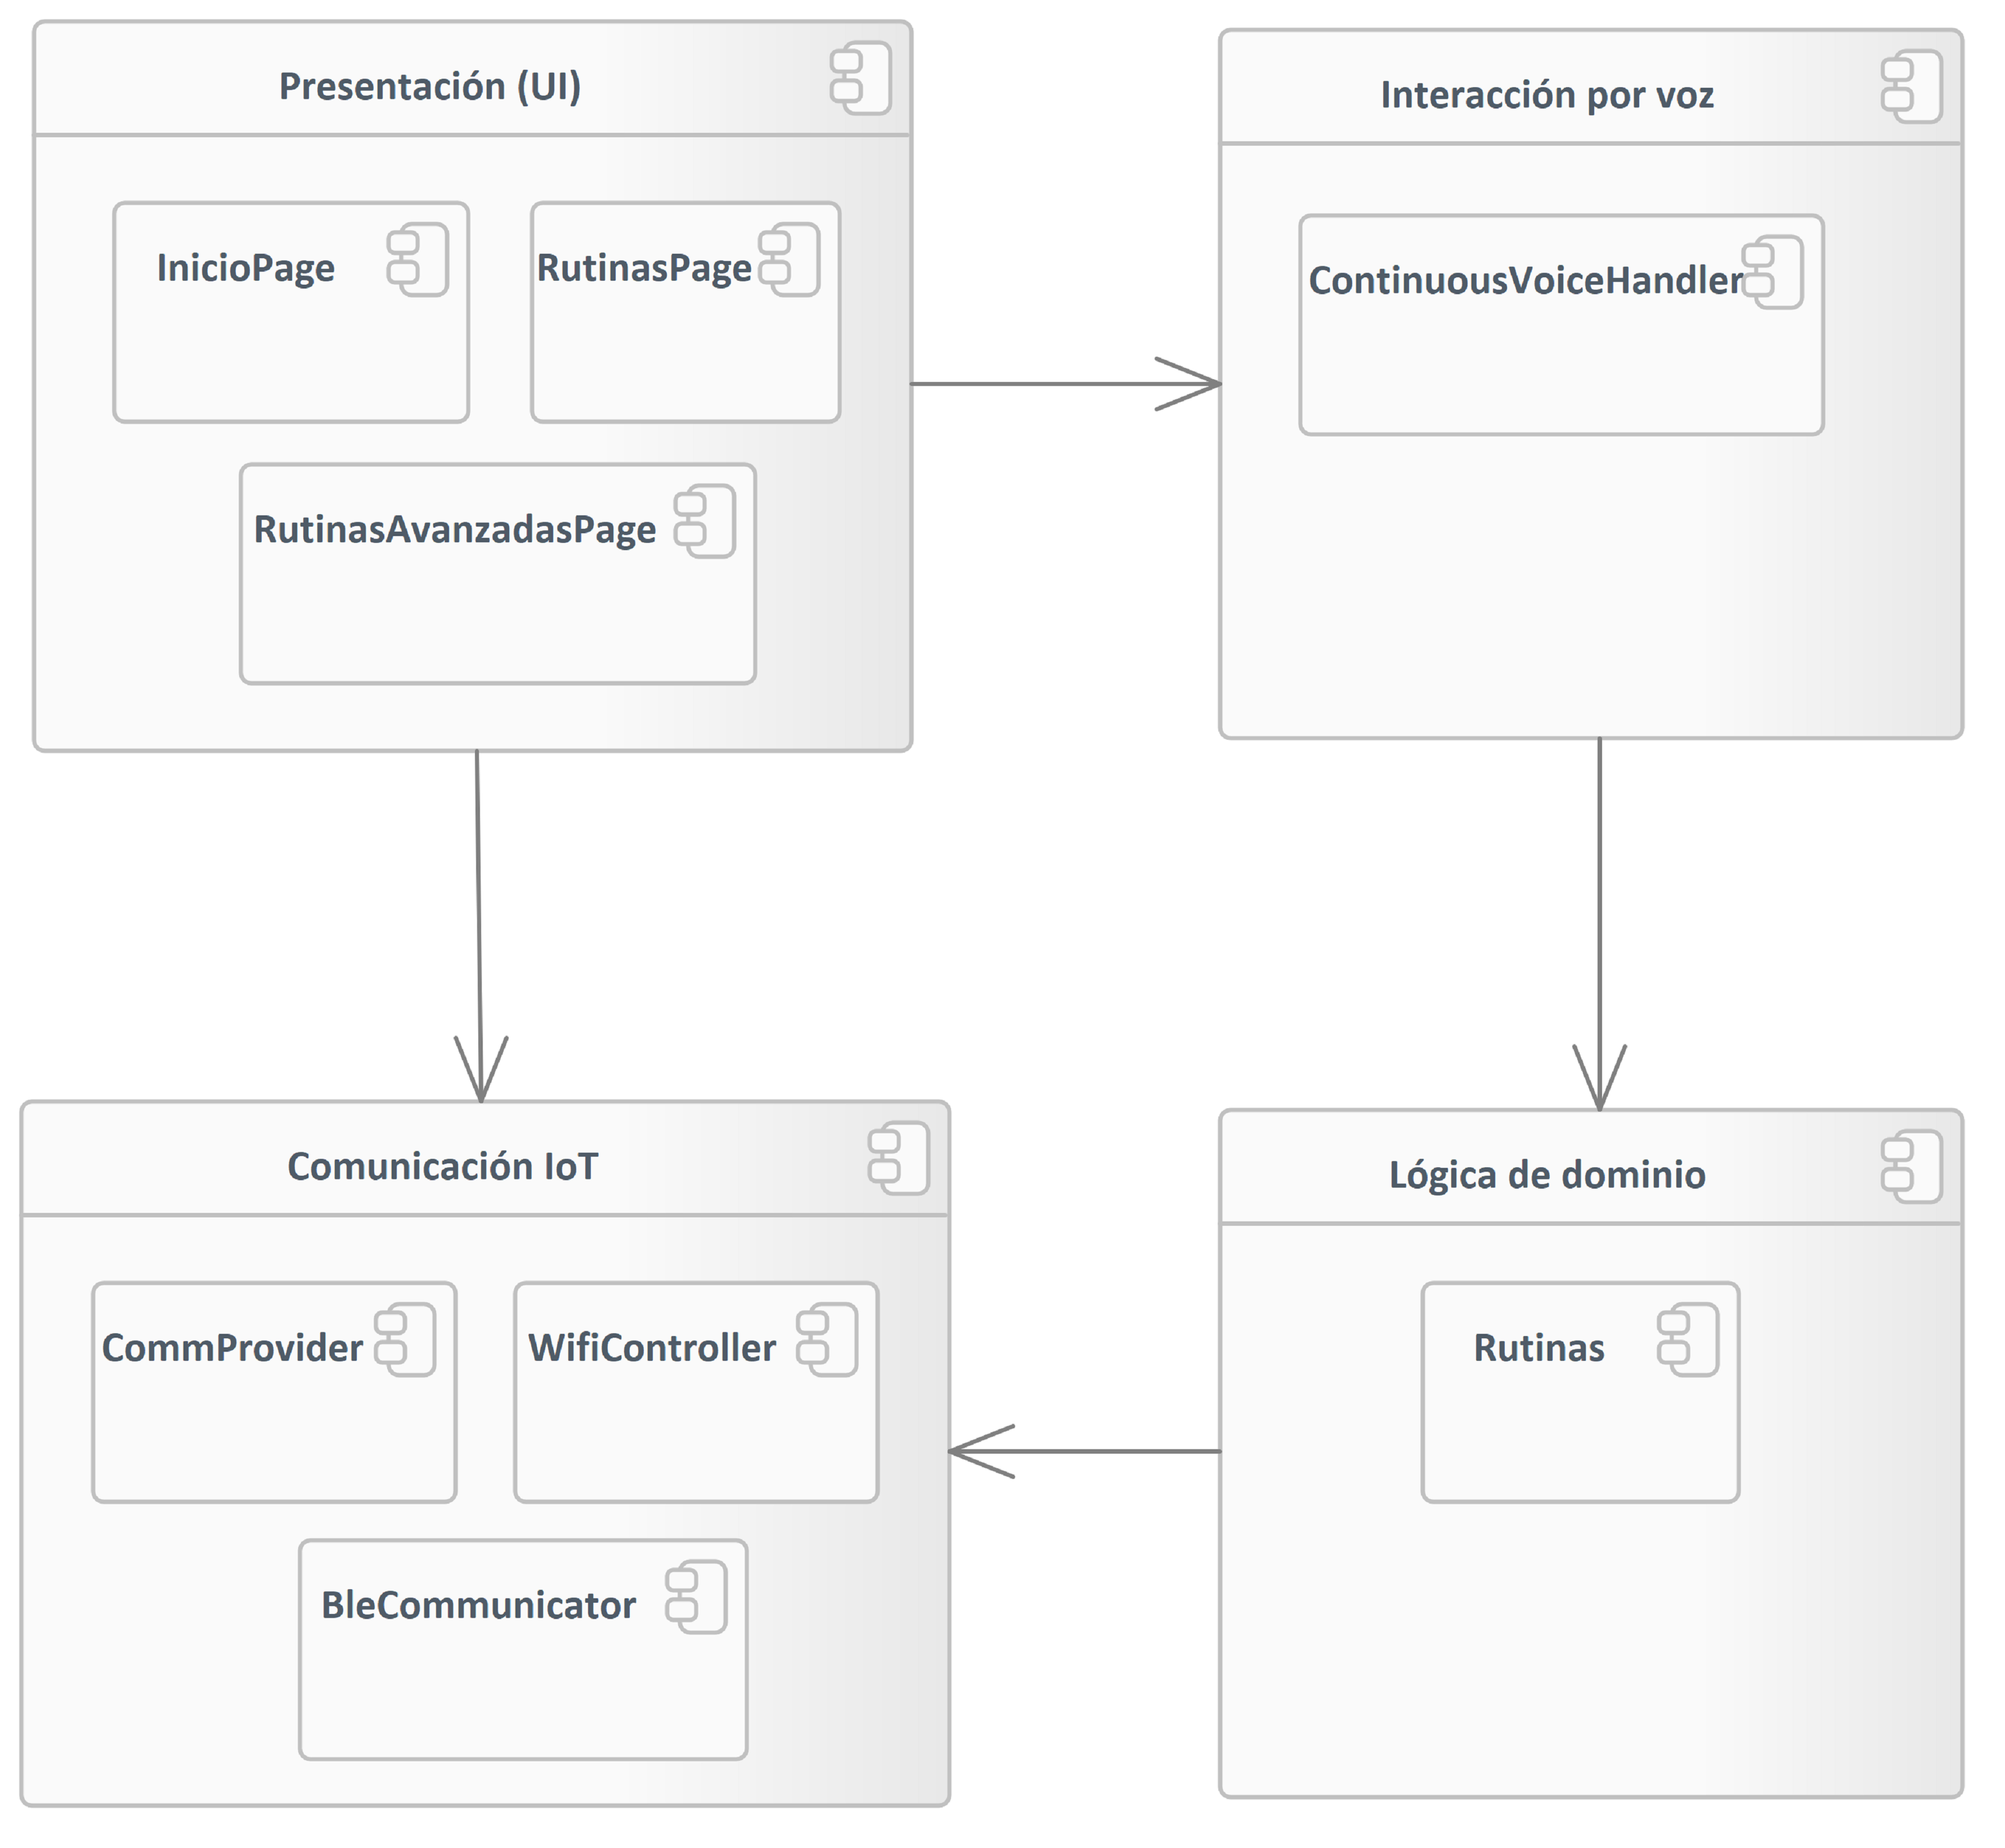

1. componente

### Component1

Package in package 'componente'

Component1

Version 1.0 Phase 1.0 Proposed

carpi created on 29/4/2025. Last modified 29/4/2025

### Class1

Class in package 'componente'

Class1

Version 1.0 Phase 1.0 Proposed

carpi created on 29/4/2025. Last modified 29/4/2025

### Interface1

Interface in package 'componente'

Interface1

Version 1.0 Phase 1.0 Proposed

carpi created on 29/4/2025. Last modified 29/4/2025

### Object1

Object in package 'componente'

Object1

Version 1.0 Phase 1.0 Proposed

carpi created on 29/4/2025. Last modified 29/4/2025

### Component1

Component in package 'componente'

Component1

Version 1.0 Phase 1.0 Proposed

carpi created on 29/4/2025. Last modified 29/4/2025

### Component2

Component «Service» in package 'componente'

Component2

Version 1.0 Phase 1.0 Proposed

carpi created on 29/4/2025. Last modified 29/4/2025

### Component3

Component «Specification» in package 'componente'

Component3

Version 1.0 Phase 1.0 Proposed

carpi created on 29/4/2025. Last modified 29/4/2025

### Comunicación IoT

Component in package 'componente'

Comunicación IoT

Version 1.0 Phase 1.0 Proposed

carpi created on 29/4/2025. Last modified 29/4/2025

| ELEMENTS OWNED BY Comunicación IoT |
| --- |
| BleCommunicator : Component |
| CommProvider : Component |
| WifiController : Component |

| ASSOCIATIONS | |
| --- | --- |
| Association (direction: Source -> Destination) | |
| Source: Public (Component) Lógica de dominio | Target: Public (Component) Comunicación IoT |
| Association (direction: Source -> Destination) | |
| Source: Public (Component) Presentación (UI) | Target: Public (Component) Comunicación IoT |

#### BleCommunicator

Component owned by 'Comunicación IoT', in package 'componente'

BleCommunicator

Version 1.0 Phase 1.0 Proposed

carpi created on 29/4/2025. Last modified 29/4/2025

#### CommProvider

Component owned by 'Comunicación IoT', in package 'componente'

CommProvider

Version 1.0 Phase 1.0 Proposed

carpi created on 29/4/2025. Last modified 29/4/2025

#### WifiController

Component owned by 'Comunicación IoT', in package 'componente'

WifiController

Version 1.0 Phase 1.0 Proposed

carpi created on 29/4/2025. Last modified 29/4/2025

### Interacción por voz

Component in package 'componente'

Interacción por voz

Version 1.0 Phase 1.0 Proposed

carpi created on 29/4/2025. Last modified 29/4/2025

| ELEMENTS OWNED BY Interacción por voz |
| --- |
| ContinuousVoiceHandler : Component |

| ASSOCIATIONS | |
| --- | --- |
| Association (direction: Source -> Destination) | |
| Source: Public (Component) Interacción por voz | Target: Public (Component) Lógica de dominio |
| Association (direction: Source -> Destination) | |
| Source: Public (Component) Presentación (UI) | Target: Public (Component) Interacción por voz |

#### ContinuousVoiceHandler

Component owned by 'Interacción por voz', in package 'componente'

ContinuousVoiceHandler

Version 1.0 Phase 1.0 Proposed

carpi created on 29/4/2025. Last modified 29/4/2025

### Lógica de dominio

Component in package 'componente'

Lógica de dominio

Version 1.0 Phase 1.0 Proposed

carpi created on 29/4/2025. Last modified 29/4/2025

| ELEMENTS OWNED BY Lógica de dominio |
| --- |
| Rutinas : Component |

| ASSOCIATIONS | |
| --- | --- |
| Association (direction: Source -> Destination) | |
| Source: Public (Component) Lógica de dominio | Target: Public (Component) Comunicación IoT |
| Association (direction: Source -> Destination) | |
| Source: Public (Component) Interacción por voz | Target: Public (Component) Lógica de dominio |

#### Rutinas

Component owned by 'Lógica de dominio', in package 'componente'

Rutinas

Version 1.0 Phase 1.0 Proposed

carpi created on 29/4/2025. Last modified 29/4/2025

### Presentación (UI)

Component in package 'componente'

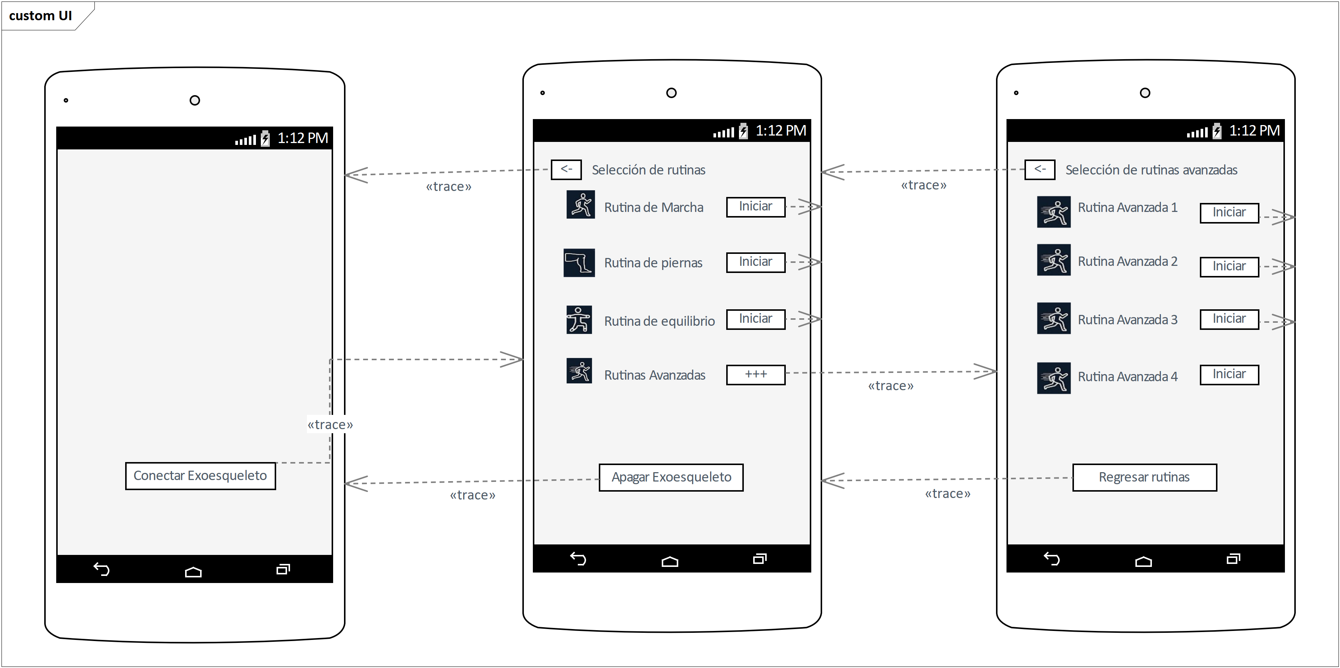

## Requerimientos

Package in package 'Model'

Requerimientos

Version 1.0 Phase 1.0 Proposed

carpi created on 25/4/2025. Last modified 25/4/2025

### Requerimientos diagram

Requirements diagram in package 'Requerimientos'

Requerimientos

Version 1.0

carpi created on 25/4/2025. Last modified 28/4/2025

1. Requerimientos

### Funcionales

FunctionalRequirement «FunctionalRequirement» in package 'Requerimientos'

Funcionales

Version 1.0 Phase 1.0 Proposed

carpi created on 25/4/2025. Last modified 28/4/2025

| ELEMENTS OWNED BY Funcionales |
| --- |
| El medico requiere que se pueda conectar mediante BLE (opcional) con el exoesqueleto. : FunctionalRequirement «FunctionalRequirement» |
| El médico requiere en el programa el poder visualizar lista de rutinas avanzadas. : FunctionalRequirement «FunctionalRequirement» |
| El médico requiere en el programa el poder visualizar lista de rutinas normales. : FunctionalRequirement «FunctionalRequirement» |
| El médico requiere que el programa inicie la rutina seleccionada (normal o avanzada) : FunctionalRequirement «FunctionalRequirement» |
| El médico requiere que el programa muestre alertas de error de conexión (WiFi/BLE). : FunctionalRequirement «FunctionalRequirement» |
| El médico requiere que el programa permita la desconexión manual del exoesqueleto : FunctionalRequirement «FunctionalRequirement» |
| El médico requiere que el programa pueda escuchar comandos de voz para seleccionar rutinas avanzadas. : FunctionalRequirement «FunctionalRequirement» |
| El médico requiere que el programa pueda escuchar comandos de voz para seleccionar rutinas normales. : FunctionalRequirement «FunctionalRequirement» |
| El médico requiere que el programa se conecte automáticamente a la red WiFi del exoesqueleto : FunctionalRequirement «FunctionalRequirement» |
| El médico requiere que el programa tenga un feedback visual del estado del asistente de voz (activo/desactivado). : FunctionalRequirement «FunctionalRequirement» |
| El médico requiere que el programa tenga una desconexión automática al cerrar la app o salir de la rutina. : FunctionalRequirement «FunctionalRequirement» |
| El médico requiere que las rutinas se puedan activar y desactivar el asistente de voz.  : FunctionalRequirement «FunctionalRequirement» |

#### El medico requiere que se pueda conectar mediante BLE (opcional) con el exoesqueleto.

FunctionalRequirement «FunctionalRequirement» owned by 'Funcionales', in package 'Requerimientos'

El medico requiere que se pueda conectar mediante BLE (opcional) con el exoesqueleto.

Version 1.0 Phase 1.0 Proposed

minec created on 28/4/2025. Last modified 28/4/2025

#### El médico requiere en el programa el poder visualizar lista de rutinas avanzadas.

FunctionalRequirement «FunctionalRequirement» owned by 'Funcionales', in package 'Requerimientos'

El médico requiere en el programa el poder visualizar lista de rutinas avanzadas.

Version 1.0 Phase 1.0 Proposed

minec created on 28/4/2025. Last modified 28/4/2025

#### El médico requiere en el programa el poder visualizar lista de rutinas normales.

FunctionalRequirement «FunctionalRequirement» owned by 'Funcionales', in package 'Requerimientos'

El médico requiere en el programa el poder visualizar lista de rutinas normales.

Version 1.0 Phase 1.0 Proposed

minec created on 28/4/2025. Last modified 28/4/2025

#### El médico requiere que el programa inicie la rutina seleccionada (normal o avanzada)

FunctionalRequirement «FunctionalRequirement» owned by 'Funcionales', in package 'Requerimientos'

El médico requiere que el programa inicie la rutina seleccionada (normal o avanzada)

Version 1.0 Phase 1.0 Proposed

minec created on 28/4/2025. Last modified 28/4/2025

#### El médico requiere que el programa muestre alertas de error de conexión (WiFi/BLE).

FunctionalRequirement «FunctionalRequirement» owned by 'Funcionales', in package 'Requerimientos'

El médico requiere que el programa muestre alertas de error de conexión (WiFi/BLE).

Version 1.0 Phase 1.0 Proposed

minec created on 28/4/2025. Last modified 28/4/2025

#### El médico requiere que el programa permita la desconexión manual del exoesqueleto

FunctionalRequirement «FunctionalRequirement» owned by 'Funcionales', in package 'Requerimientos'

El médico requiere que el programa permita la desconexión manual del exoesqueleto

Version 1.0 Phase 1.0 Proposed

minec created on 28/4/2025. Last modified 28/4/2025

#### El médico requiere que el programa pueda escuchar comandos de voz para seleccionar rutinas avanzadas.

FunctionalRequirement «FunctionalRequirement» owned by 'Funcionales', in package 'Requerimientos'

El médico requiere que el programa pueda escuchar comandos de voz para seleccionar rutinas avanzadas.

Version 1.0 Phase 1.0 Proposed

minec created on 28/4/2025. Last modified 28/4/2025

#### El médico requiere que el programa pueda escuchar comandos de voz para seleccionar rutinas normales.

FunctionalRequirement «FunctionalRequirement» owned by 'Funcionales', in package 'Requerimientos'

El médico requiere que el programa pueda escuchar comandos de voz para seleccionar rutinas normales.

Version 1.0 Phase 1.0 Proposed

minec created on 28/4/2025. Last modified 28/4/2025

#### El médico requiere que el programa se conecte automáticamente a la red WiFi del exoesqueleto

FunctionalRequirement «FunctionalRequirement» owned by 'Funcionales', in package 'Requerimientos'

El médico requiere que el programa se conecte automáticamente a la red WiFi del exoesqueleto

Version 1.0 Phase 1.0 Proposed

minec created on 28/4/2025. Last modified 28/4/2025

#### El médico requiere que el programa tenga un feedback visual del estado del asistente de voz (activo/desactivado).

FunctionalRequirement «FunctionalRequirement» owned by 'Funcionales', in package 'Requerimientos'

El médico requiere que el programa tenga un feedback visual del estado del asistente de voz (activo/desactivado).

Version 1.0 Phase 1.0 Proposed

minec created on 28/4/2025. Last modified 28/4/2025

#### El médico requiere que el programa tenga una desconexión automática al cerrar la app o salir de la rutina.

FunctionalRequirement «FunctionalRequirement» owned by 'Funcionales', in package 'Requerimientos'

El médico requiere que el programa tenga una desconexión automática al cerrar la app o salir de la rutina.

Version 1.0 Phase 1.0 Proposed

minec created on 28/4/2025. Last modified 28/4/2025

#### El médico requiere que las rutinas se puedan activar y desactivar el asistente de voz.

FunctionalRequirement «FunctionalRequirement» owned by 'Funcionales', in package 'Requerimientos'

El médico requiere que las rutinas se puedan activar y desactivar el asistente de voz.

Version 1.0 Phase 1.0 Proposed

minec created on 28/4/2025. Last modified 28/4/2025

### No funcionales

Requirement in package 'Requerimientos'

No funcionales

Version 1.0 Phase 1.0 Proposed

carpi created on 25/4/2025. Last modified 25/4/2025

| ELEMENTS OWNED BY No funcionales |
| --- |
| + : Requirement |
| Facilidad de uso : Requirement |
| Fiabilidad : Requirement |
| Rendimiento : Requirement |
| Soporte : Requirement |

#### +

Requirement owned by 'No funcionales', in package 'Requerimientos'

+

Version 1.0 Phase 1.0 Proposed

carpi created on 25/4/2025. Last modified 25/4/2025

| ELEMENTS OWNED BY + |
| --- |
| El sistema debe de permitir integración con sensores adicionales en futuras versiones. : NonfunctionalRequirement «NonfunctionalRequirement» |
| El sistema debe de poder manejar posibles errores de conexión de manera segura sin bloquear la app. : NonfunctionalRequirement «NonfunctionalRequirement» |
| El sistema debe de tener adaptabilidad a diferentes tamaños de pantalla Android.  : NonfunctionalRequirement «NonfunctionalRequirement» |

##### El sistema debe de permitir integración con sensores adicionales en futuras versiones.

NonfunctionalRequirement «NonfunctionalRequirement» owned by '+', in package 'Requerimientos'

El sistema debe de permitir integración con sensores adicionales en futuras versiones.

Version 1.0 Phase 1.0 Proposed

minec created on 28/4/2025. Last modified 28/4/2025

##### El sistema debe de poder manejar posibles errores de conexión de manera segura sin bloquear la app.

NonfunctionalRequirement «NonfunctionalRequirement» owned by '+', in package 'Requerimientos'

El sistema debe de poder manejar posibles errores de conexión de manera segura sin bloquear la app.

Version 1.0 Phase 1.0 Proposed

minec created on 28/4/2025. Last modified 28/4/2025

##### El sistema debe de tener adaptabilidad a diferentes tamaños de pantalla Android.

NonfunctionalRequirement «NonfunctionalRequirement» owned by '+', in package 'Requerimientos'

El sistema debe de tener adaptabilidad a diferentes tamaños de pantalla Android.

Version 1.0 Phase 1.0 Proposed

minec created on 28/4/2025. Last modified 28/4/2025

#### Facilidad de uso

Requirement owned by 'No funcionales', in package 'Requerimientos'

Facilidad de uso

Version 1.0 Phase 1.0 Proposed

carpi created on 25/4/2025. Last modified 25/4/2025

| ELEMENTS OWNED BY Facilidad de uso |
| --- |
| El sistema debe de tener botones de gran tamaño y accesibles. : FunctionalRequirement «FunctionalRequirement» |
| El sistema debe de tener una activación sencilla del control por voz con un solo comando ("iniciar").  : FunctionalRequirement «FunctionalRequirement» |
| El sistema debe de tener una interfaz gráfica amigable, intuitiva y adaptada a usuarios clínicos o pacientes. : FunctionalRequirement «FunctionalRequirement» |

##### El sistema debe de tener botones de gran tamaño y accesibles.

FunctionalRequirement «FunctionalRequirement» owned by 'Facilidad de uso', in package 'Requerimientos'

El sistema debe de tener botones de gran tamaño y accesibles.

Version 1.0 Phase 1.0 Proposed

minec created on 28/4/2025. Last modified 28/4/2025

##### El sistema debe de tener una activación sencilla del control por voz con un solo comando ("iniciar").

FunctionalRequirement «FunctionalRequirement» owned by 'Facilidad de uso', in package 'Requerimientos'

El sistema debe de tener una activación sencilla del control por voz con un solo comando ("iniciar").

Version 1.0 Phase 1.0 Proposed

minec created on 28/4/2025. Last modified 28/4/2025

##### El sistema debe de tener una interfaz gráfica amigable, intuitiva y adaptada a usuarios clínicos o pacientes.

FunctionalRequirement «FunctionalRequirement» owned by 'Facilidad de uso', in package 'Requerimientos'

El sistema debe de tener una interfaz gráfica amigable, intuitiva y adaptada a usuarios clínicos o pacientes.

Version 1.0 Phase 1.0 Proposed

minec created on 28/4/2025. Last modified 28/4/2025

#### Fiabilidad

Requirement owned by 'No funcionales', in package 'Requerimientos'

Fiabilidad

Version 1.0 Phase 1.0 Proposed

carpi created on 25/4/2025. Last modified 25/4/2025

| ELEMENTS OWNED BY Fiabilidad |
| --- |
| El sistema debe de tener un reconocimiento robusto de comandos de voz en ambiente hospitalario o de rehabilitación.  : NonfunctionalRequirement «NonfunctionalRequirement» |
| El sistema debe de tener una conexión estable vía WiFi o BLE sin pérdidas durante la ejecución de rutinas. : NonfunctionalRequirement «NonfunctionalRequirement» |

##### El sistema debe de tener un reconocimiento robusto de comandos de voz en ambiente hospitalario o de rehabilitación.

NonfunctionalRequirement «NonfunctionalRequirement» owned by 'Fiabilidad', in package 'Requerimientos'

El sistema debe de tener un reconocimiento robusto de comandos de voz en ambiente hospitalario o de rehabilitación.

Version 1.0 Phase 1.0 Proposed

minec created on 28/4/2025. Last modified 28/4/2025

##### El sistema debe de tener una conexión estable vía WiFi o BLE sin pérdidas durante la ejecución de rutinas.

NonfunctionalRequirement «NonfunctionalRequirement» owned by 'Fiabilidad', in package 'Requerimientos'

El sistema debe de tener una conexión estable vía WiFi o BLE sin pérdidas durante la ejecución de rutinas.

Version 1.0 Phase 1.0 Proposed

minec created on 28/4/2025. Last modified 28/4/2025

#### Rendimiento

Requirement owned by 'No funcionales', in package 'Requerimientos'

Rendimiento

Version 1.0 Phase 1.0 Proposed

carpi created on 25/4/2025. Last modified 25/4/2025

| ELEMENTS OWNED BY Rendimiento |
| --- |
| El sistema debe de tener baja latencia en la comunicación WiFi/BLE. : NonfunctionalRequirement «NonfunctionalRequirement» |
| El sistema debe de tener una respuesta inmediata al seleccionar una rutina o al usar comandos de voz (< 1 segundo de retardo). : NonfunctionalRequirement «NonfunctionalRequirement» |

##### El sistema debe de tener baja latencia en la comunicación WiFi/BLE.

NonfunctionalRequirement «NonfunctionalRequirement» owned by 'Rendimiento', in package 'Requerimientos'

El sistema debe de tener baja latencia en la comunicación WiFi/BLE.

Version 1.0 Phase 1.0 Proposed

minec created on 28/4/2025. Last modified 28/4/2025

##### El sistema debe de tener una respuesta inmediata al seleccionar una rutina o al usar comandos de voz (< 1 segundo de retardo).

NonfunctionalRequirement «NonfunctionalRequirement» owned by 'Rendimiento', in package 'Requerimientos'

El sistema debe de tener una respuesta inmediata al seleccionar una rutina o al usar comandos de voz (< 1 segundo de retardo).

Version 1.0 Phase 1.0 Proposed

minec created on 28/4/2025. Last modified 28/4/2025

#### Soporte

Requirement owned by 'No funcionales', in package 'Requerimientos'

Soporte

Version 1.0 Phase 1.0 Proposed

carpi created on 25/4/2025. Last modified 25/4/2025

| ELEMENTS OWNED BY Soporte |
| --- |
| El sistema debe de tener compatibilidad prevista para futuras extensiones como nuevos tipos de exoesqueletos o rutinas personalizadas.  : NonfunctionalRequirement «NonfunctionalRequirement» |
| El sistema debe de tener un módulo que permita actualizar fácilmente la app para agregar nuevas rutinas. : NonfunctionalRequirement «NonfunctionalRequirement» |

##### El sistema debe de tener compatibilidad prevista para futuras extensiones como nuevos tipos de exoesqueletos o rutinas personalizadas.

NonfunctionalRequirement «NonfunctionalRequirement» owned by 'Soporte', in package 'Requerimientos'

El sistema debe de tener compatibilidad prevista para futuras extensiones como nuevos tipos de exoesqueletos o rutinas personalizadas.

Version 1.0 Phase 1.0 Proposed

minec created on 28/4/2025. Last modified 28/4/2025

##### El sistema debe de tener un módulo que permita actualizar fácilmente la app para agregar nuevas rutinas.

NonfunctionalRequirement «NonfunctionalRequirement» owned by 'Soporte', in package 'Requerimientos'

El sistema debe de tener un módulo que permita actualizar fácilmente la app para agregar nuevas rutinas.

Version 1.0 Phase 1.0 Proposed

minec created on 28/4/2025. Last modified 28/4/2025

## UI

Package in package 'Model'

UI

Version 1.0 Phase 1.0 Proposed

carpi created on 25/4/2025. Last modified 25/4/2025

### UI diagram

Android Wireframe diagram in package 'UI'

UI

Version 1.0

carpi created on 25/4/2025. Last modified 29/4/2025

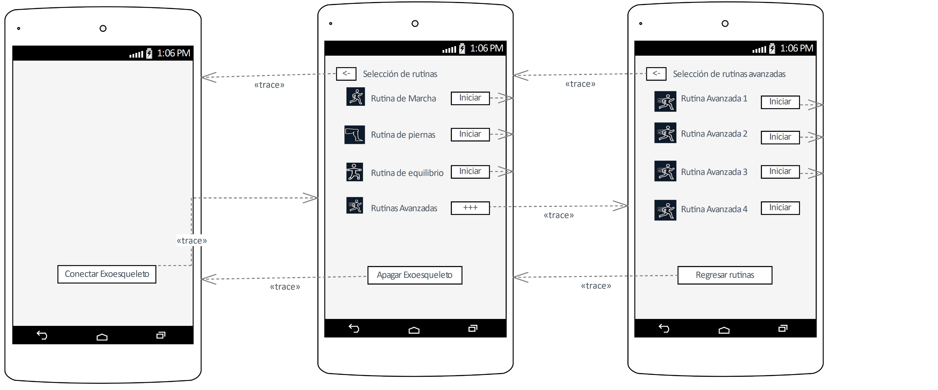

1. UI

### Boundary

Boundary in package 'UI'

Boundary

Version 1.0 Phase 1.0 Proposed

carpi created on 25/4/2025. Last modified 25/4/2025

Extends

### Boundary

Boundary in package 'UI'

Boundary

Version 1.0 Phase 1.0 Proposed

carpi created on 25/4/2025. Last modified 25/4/2025

Extends

### Boundary

Boundary in package 'UI'

Boundary

Version 1.0 Phase 1.0 Proposed

carpi created on 25/4/2025. Last modified 25/4/2025

Extends

### Boundary

Boundary in package 'UI'

Boundary

Version 1.0 Phase 1.0 Proposed

carpi created on 25/4/2025. Last modified 25/4/2025

Extends

### Boundary

Boundary in package 'UI'

Boundary

Version 1.0 Phase 1.0 Proposed

carpi created on 25/4/2025. Last modified 25/4/2025

Extends

### Boundary

Boundary in package 'UI'

Boundary

Version 1.0 Phase 1.0 Proposed

carpi created on 25/4/2025. Last modified 25/4/2025

Extends

### Boundary

Boundary in package 'UI'

Boundary

Version 1.0 Phase 1.0 Proposed

carpi created on 25/4/2025. Last modified 25/4/2025

Extends

### Boundary

Boundary in package 'UI'

Boundary

Version 1.0 Phase 1.0 Proposed

carpi created on 25/4/2025. Last modified 25/4/2025

Extends

### AndroidPhone1

AndroidPhone «WireframeAndroidPhone» in package 'UI'

AndroidPhone1

Version 1.0 Phase 1.0 Proposed

carpi created on 25/4/2025. Last modified 25/4/2025

Extends

| CONNECTORS |
| --- |
| Trace «trace» Source -> Destination  From: Apagar Exoesqueleto : Button, Public  To: AndroidPhone1 : AndroidPhone, Public |
| Trace «trace» Source -> Destination  From: <- : Button, Public  To: AndroidPhone1 : AndroidPhone, Public |

#### Conectar Exoesqueleto

Button «WireframeAndroidButton» owned by 'AndroidPhone1', in package 'UI'

Conectar Exoesqueleto

Version 1.0 Phase 1.0 Proposed

carpi created on 25/4/2025. Last modified 25/4/2025

Extends

| CONNECTORS |
| --- |
| Trace «trace» Source -> Destination  From: Conectar Exoesqueleto : Button, Public  To: AndroidPhone2 : AndroidPhone, Public |

### AndroidPhone2

AndroidPhone «WireframeAndroidPhone» in package 'UI'

AndroidPhone2

Version 1.0 Phase 1.0 Proposed

carpi created on 25/4/2025. Last modified 25/4/2025

Extends

| CONNECTORS |
| --- |
| Trace «trace» Source -> Destination  From: Conectar Exoesqueleto : Button, Public  To: AndroidPhone2 : AndroidPhone, Public |
| Trace «trace» Source -> Destination  From: Iniciar : Button, Public  To: AndroidPhone2 : AndroidPhone, Public |
| Trace «trace» Source -> Destination  From: Regresar rutinas : Button, Public  To: AndroidPhone2 : AndroidPhone, Public |
| Trace «trace» Source -> Destination  From: <- : Button, Public  To: AndroidPhone2 : AndroidPhone, Public |
| Trace «trace» Source -> Destination  From: Iniciar : Button, Public  To: AndroidPhone2 : AndroidPhone, Public |
| Trace «trace» Source -> Destination  From: Iniciar : Button, Public  To: AndroidPhone2 : AndroidPhone, Public |

#### rut_equilibrioN.png

Artifact «Image» owned by 'AndroidPhone2', in package 'UI'

rut_equilibrioN.png

Version 1.0 Phase 1.0 Proposed

carpi created on 25/4/2025. Last modified 25/4/2025

#### rut_piernasN.png

Artifact «Image» owned by 'AndroidPhone2', in package 'UI'

rut_piernasN.png

Version 1.0 Phase 1.0 Proposed

carpi created on 25/4/2025. Last modified 25/4/2025

| ELEMENTS OWNED BY rut_piernasN.png |
| --- |
| rut_marchaN.png : Artifact «Image» |

##### rut_marchaN.png

Artifact «Image» owned by 'rut_piernasN.png', in package 'UI'

rut_marchaN.png

Version 1.0 Phase 1.0 Proposed

carpi created on 25/4/2025. Last modified 25/4/2025

#### rut_reha_avanzadaN.png

Artifact «Image» owned by 'AndroidPhone2', in package 'UI'

rut_reha_avanzadaN.png

Version 1.0 Phase 1.0 Proposed

carpi created on 25/4/2025. Last modified 25/4/2025

#### +++

Button «WireframeAndroidButton» owned by 'AndroidPhone2', in package 'UI'

+++

Version 1.0 Phase 1.0 Proposed

carpi created on 25/4/2025. Last modified 25/4/2025

Extends

| CONNECTORS |
| --- |
| Trace «trace» Source -> Destination  From: +++ : Button, Public  To: AndroidPhone2 : AndroidPhone, Public |

#### <-

Button «WireframeAndroidButton» owned by 'AndroidPhone2', in package 'UI'

<-

Version 1.0 Phase 1.0 Proposed

carpi created on 25/4/2025. Last modified 25/4/2025

Extends

| CONNECTORS |
| --- |
| Trace «trace» Source -> Destination  From: <- : Button, Public  To: AndroidPhone1 : AndroidPhone, Public |

#### Apagar Exoesqueleto

Button «WireframeAndroidButton» owned by 'AndroidPhone2', in package 'UI'

Apagar Exoesqueleto

Version 1.0 Phase 1.0 Proposed

carpi created on 25/4/2025. Last modified 25/4/2025

Extends

| CONNECTORS |
| --- |
| Trace «trace» Source -> Destination  From: Apagar Exoesqueleto : Button, Public  To: AndroidPhone1 : AndroidPhone, Public |

#### Iniciar

Button «WireframeAndroidButton» owned by 'AndroidPhone2', in package 'UI'

Iniciar

Version 1.0 Phase 1.0 Proposed

carpi created on 25/4/2025. Last modified 25/4/2025

Extends

| CONNECTORS |
| --- |
| Trace «trace» Source -> Destination  From: Iniciar : Button, Public  To: AndroidPhone2 : AndroidPhone, Public |

#### Iniciar

Button «WireframeAndroidButton» owned by 'AndroidPhone2', in package 'UI'

Iniciar

Version 1.0 Phase 1.0 Proposed

carpi created on 25/4/2025. Last modified 25/4/2025

Extends

| CONNECTORS |
| --- |
| Trace «trace» Source -> Destination  From: Iniciar : Button, Public  To: AndroidPhone2 : AndroidPhone, Public |

#### Iniciar

Button «WireframeAndroidButton» owned by 'AndroidPhone2', in package 'UI'

Iniciar

Version 1.0 Phase 1.0 Proposed

carpi created on 25/4/2025. Last modified 25/4/2025

Extends

| CONNECTORS |
| --- |
| Trace «trace» Source -> Destination  From: Iniciar : Button, Public  To: AndroidPhone2 : AndroidPhone, Public |

#### Rutina de equilibrio

Label «WireframeLabel» owned by 'AndroidPhone2', in package 'UI'

Rutina de equilibrio

Version 1.0 Phase 1.0 Proposed

carpi created on 25/4/2025. Last modified 25/4/2025

Extends

#### Rutina de Marcha

Label «WireframeLabel» owned by 'AndroidPhone2', in package 'UI'

Rutina de Marcha

Version 1.0 Phase 1.0 Proposed

carpi created on 25/4/2025. Last modified 25/4/2025

Extends

#### Rutina de piernas

Label «WireframeLabel» owned by 'AndroidPhone2', in package 'UI'

Rutina de piernas

Version 1.0 Phase 1.0 Proposed

carpi created on 25/4/2025. Last modified 25/4/2025

Extends

#### Rutinas Avanzadas

Label «WireframeLabel» owned by 'AndroidPhone2', in package 'UI'

Rutinas Avanzadas

Version 1.0 Phase 1.0 Proposed

carpi created on 25/4/2025. Last modified 25/4/2025

Extends

#### Selección de rutinas

Label «WireframeLabel» owned by 'AndroidPhone2', in package 'UI'

Selección de rutinas

Version 1.0 Phase 1.0 Proposed

carpi created on 25/4/2025. Last modified 25/4/2025

Extends

#### UI Control

GUIElement «WireframeImage» owned by 'AndroidPhone2', in package 'UI'

UI Control

Version 1.0 Phase 1.0 Proposed

carpi created on 25/4/2025. Last modified 25/4/2025

Extends

#### UI Control

GUIElement «WireframeImage» owned by 'AndroidPhone2', in package 'UI'

UI Control

Version 1.0 Phase 1.0 Proposed

carpi created on 25/4/2025. Last modified 25/4/2025

Extends

#### UI Control

GUIElement «WireframeImage» owned by 'AndroidPhone2', in package 'UI'

UI Control

Version 1.0 Phase 1.0 Proposed

carpi created on 25/4/2025. Last modified 25/4/2025

Extends

#### UI Control

GUIElement «WireframeImage» owned by 'AndroidPhone2', in package 'UI'

UI Control

Version 1.0 Phase 1.0 Proposed

carpi created on 25/4/2025. Last modified 25/4/2025

Extends

### AndroidPhone2

AndroidPhone «WireframeAndroidPhone» in package 'UI'

AndroidPhone2

Version 1.0 Phase 1.0 Proposed

carpi created on 25/4/2025. Last modified 25/4/2025

Extends

| CONNECTORS |
| --- |
| Trace «trace» Source -> Destination  From: Iniciar : Button, Public  To: AndroidPhone2 : AndroidPhone, Public |
| Trace «trace» Source -> Destination  From: +++ : Button, Public  To: AndroidPhone2 : AndroidPhone, Public |
| Trace «trace» Source -> Destination  From: Iniciar : Button, Public  To: AndroidPhone2 : AndroidPhone, Public |
| Trace «trace» Source -> Destination  From: Iniciar : Button, Public  To: AndroidPhone2 : AndroidPhone, Public |

#### <-

Button «WireframeAndroidButton» owned by 'AndroidPhone2', in package 'UI'

<-

Version 1.0 Phase 1.0 Proposed

carpi created on 25/4/2025. Last modified 25/4/2025

Extends

| CONNECTORS |
| --- |
| Trace «trace» Source -> Destination  From: <- : Button, Public  To: AndroidPhone2 : AndroidPhone, Public |

#### Iniciar

Button «WireframeAndroidButton» owned by 'AndroidPhone2', in package 'UI'

Iniciar

Version 1.0 Phase 1.0 Proposed

carpi created on 25/4/2025. Last modified 25/4/2025

Extends

#### Iniciar

Button «WireframeAndroidButton» owned by 'AndroidPhone2', in package 'UI'

Iniciar

Version 1.0 Phase 1.0 Proposed

carpi created on 25/4/2025. Last modified 25/4/2025

Extends

| CONNECTORS |
| --- |
| Trace «trace» Source -> Destination  From: Iniciar : Button, Public  To: AndroidPhone2 : AndroidPhone, Public |

#### Iniciar

Button «WireframeAndroidButton» owned by 'AndroidPhone2', in package 'UI'

Iniciar

Version 1.0 Phase 1.0 Proposed

carpi created on 25/4/2025. Last modified 25/4/2025

Extends

| CONNECTORS |
| --- |
| Trace «trace» Source -> Destination  From: Iniciar : Button, Public  To: AndroidPhone2 : AndroidPhone, Public |

#### Iniciar

Button «WireframeAndroidButton» owned by 'AndroidPhone2', in package 'UI'

Iniciar

Version 1.0 Phase 1.0 Proposed

carpi created on 25/4/2025. Last modified 25/4/2025

Extends

| CONNECTORS |
| --- |
| Trace «trace» Source -> Destination  From: Iniciar : Button, Public  To: AndroidPhone2 : AndroidPhone, Public |

#### Regresar rutinas

Button «WireframeAndroidButton» owned by 'AndroidPhone2', in package 'UI'

Regresar rutinas

Version 1.0 Phase 1.0 Proposed

carpi created on 25/4/2025. Last modified 25/4/2025

Extends

| CONNECTORS |
| --- |
| Trace «trace» Source -> Destination  From: Regresar rutinas : Button, Public  To: AndroidPhone2 : AndroidPhone, Public |

#### Rutina Avanzada 1

Label «WireframeLabel» owned by 'AndroidPhone2', in package 'UI'

Rutina Avanzada 1

Version 1.0 Phase 1.0 Proposed

carpi created on 25/4/2025. Last modified 25/4/2025

Extends

#### Rutina Avanzada 2

Label «WireframeLabel» owned by 'AndroidPhone2', in package 'UI'

Rutina Avanzada 2

Version 1.0 Phase 1.0 Proposed

carpi created on 25/4/2025. Last modified 25/4/2025

Extends

#### Rutina Avanzada 3

Label «WireframeLabel» owned by 'AndroidPhone2', in package 'UI'

Rutina Avanzada 3

Version 1.0 Phase 1.0 Proposed

carpi created on 25/4/2025. Last modified 25/4/2025

Extends

#### Rutina Avanzada 4

Label «WireframeLabel» owned by 'AndroidPhone2', in package 'UI'

Rutina Avanzada 4

Version 1.0 Phase 1.0 Proposed

carpi created on 25/4/2025. Last modified 25/4/2025

Extends

#### Selección de rutinas avanzadas

Label «WireframeLabel» owned by 'AndroidPhone2', in package 'UI'

Selección de rutinas avanzadas

Version 1.0 Phase 1.0 Proposed

carpi created on 25/4/2025. Last modified 25/4/2025

Extends

### AndroidPhone2

AndroidPhone «WireframeAndroidPhone» in package 'UI'

AndroidPhone2

Version 1.0 Phase 1.0 Proposed

carpi created on 25/4/2025. Last modified 25/4/2025

Extends

#### +++

Button «WireframeAndroidButton» owned by 'AndroidPhone2', in package 'UI'

+++

Version 1.0 Phase 1.0 Proposed

carpi created on 25/4/2025. Last modified 25/4/2025

Extends

#### <-

Button «WireframeAndroidButton» owned by 'AndroidPhone2', in package 'UI'

<-

Version 1.0 Phase 1.0 Proposed

carpi created on 25/4/2025. Last modified 25/4/2025

Extends

#### Apagar Exoesqueleto

Button «WireframeAndroidButton» owned by 'AndroidPhone2', in package 'UI'

Apagar Exoesqueleto

Version 1.0 Phase 1.0 Proposed

carpi created on 25/4/2025. Last modified 25/4/2025

Extends

#### Iniciar

Button «WireframeAndroidButton» owned by 'AndroidPhone2', in package 'UI'

Iniciar

Version 1.0 Phase 1.0 Proposed

carpi created on 25/4/2025. Last modified 25/4/2025

Extends

#### Iniciar

Button «WireframeAndroidButton» owned by 'AndroidPhone2', in package 'UI'

Iniciar

Version 1.0 Phase 1.0 Proposed

carpi created on 25/4/2025. Last modified 25/4/2025

Extends

#### Iniciar

Button «WireframeAndroidButton» owned by 'AndroidPhone2', in package 'UI'

Iniciar

Version 1.0 Phase 1.0 Proposed

carpi created on 25/4/2025. Last modified 25/4/2025

Extends

#### Rutina de equilibrio

Label «WireframeLabel» owned by 'AndroidPhone2', in package 'UI'

Rutina de equilibrio

Version 1.0 Phase 1.0 Proposed

carpi created on 25/4/2025. Last modified 25/4/2025

Extends

#### Rutina de Marcha

Label «WireframeLabel» owned by 'AndroidPhone2', in package 'UI'

Rutina de Marcha

Version 1.0 Phase 1.0 Proposed

carpi created on 25/4/2025. Last modified 25/4/2025

Extends

#### Rutina de piernas

Label «WireframeLabel» owned by 'AndroidPhone2', in package 'UI'

Rutina de piernas

Version 1.0 Phase 1.0 Proposed

carpi created on 25/4/2025. Last modified 25/4/2025

Extends

#### Rutinas Avanzadas

Label «WireframeLabel» owned by 'AndroidPhone2', in package 'UI'

Rutinas Avanzadas

Version 1.0 Phase 1.0 Proposed

carpi created on 25/4/2025. Last modified 25/4/2025

Extends

#### Selección de rutinas

Label «WireframeLabel» owned by 'AndroidPhone2', in package 'UI'

Selección de rutinas

Version 1.0 Phase 1.0 Proposed

carpi created on 25/4/2025. Last modified 25/4/2025

Extends

### AndroidPhone3

AndroidPhone «WireframeAndroidPhone» in package 'UI'

AndroidPhone3

Version 1.0 Phase 1.0 Proposed

carpi created on 25/4/2025. Last modified 25/4/2025

Extends

### UI Control

GUIElement «WireframeImage» in package 'UI'

UI Control

Version 1.0 Phase 1.0 Proposed

carpi created on 25/4/2025. Last modified 25/4/2025

Extends

### rut_reha_avanzada.png

Artifact «Image» in package 'UI'

rut_reha_avanzada.png

Version 1.0 Phase 1.0 Proposed

carpi created on 25/4/2025. Last modified 25/4/2025

## Use Case-Documentados y Sequencia

Package in package 'Model'

Use Case-Documentados y Sequencia

Version 1.0 Phase 1.0 Proposed

carpi created on 25/4/2025. Last modified 28/4/2025

### Use Case diagram

Use Case diagram in package 'Use Case-Documentados y Sequencia'

Use Case

Version 1.0

carpi created on 25/4/2025. Last modified 28/4/2025

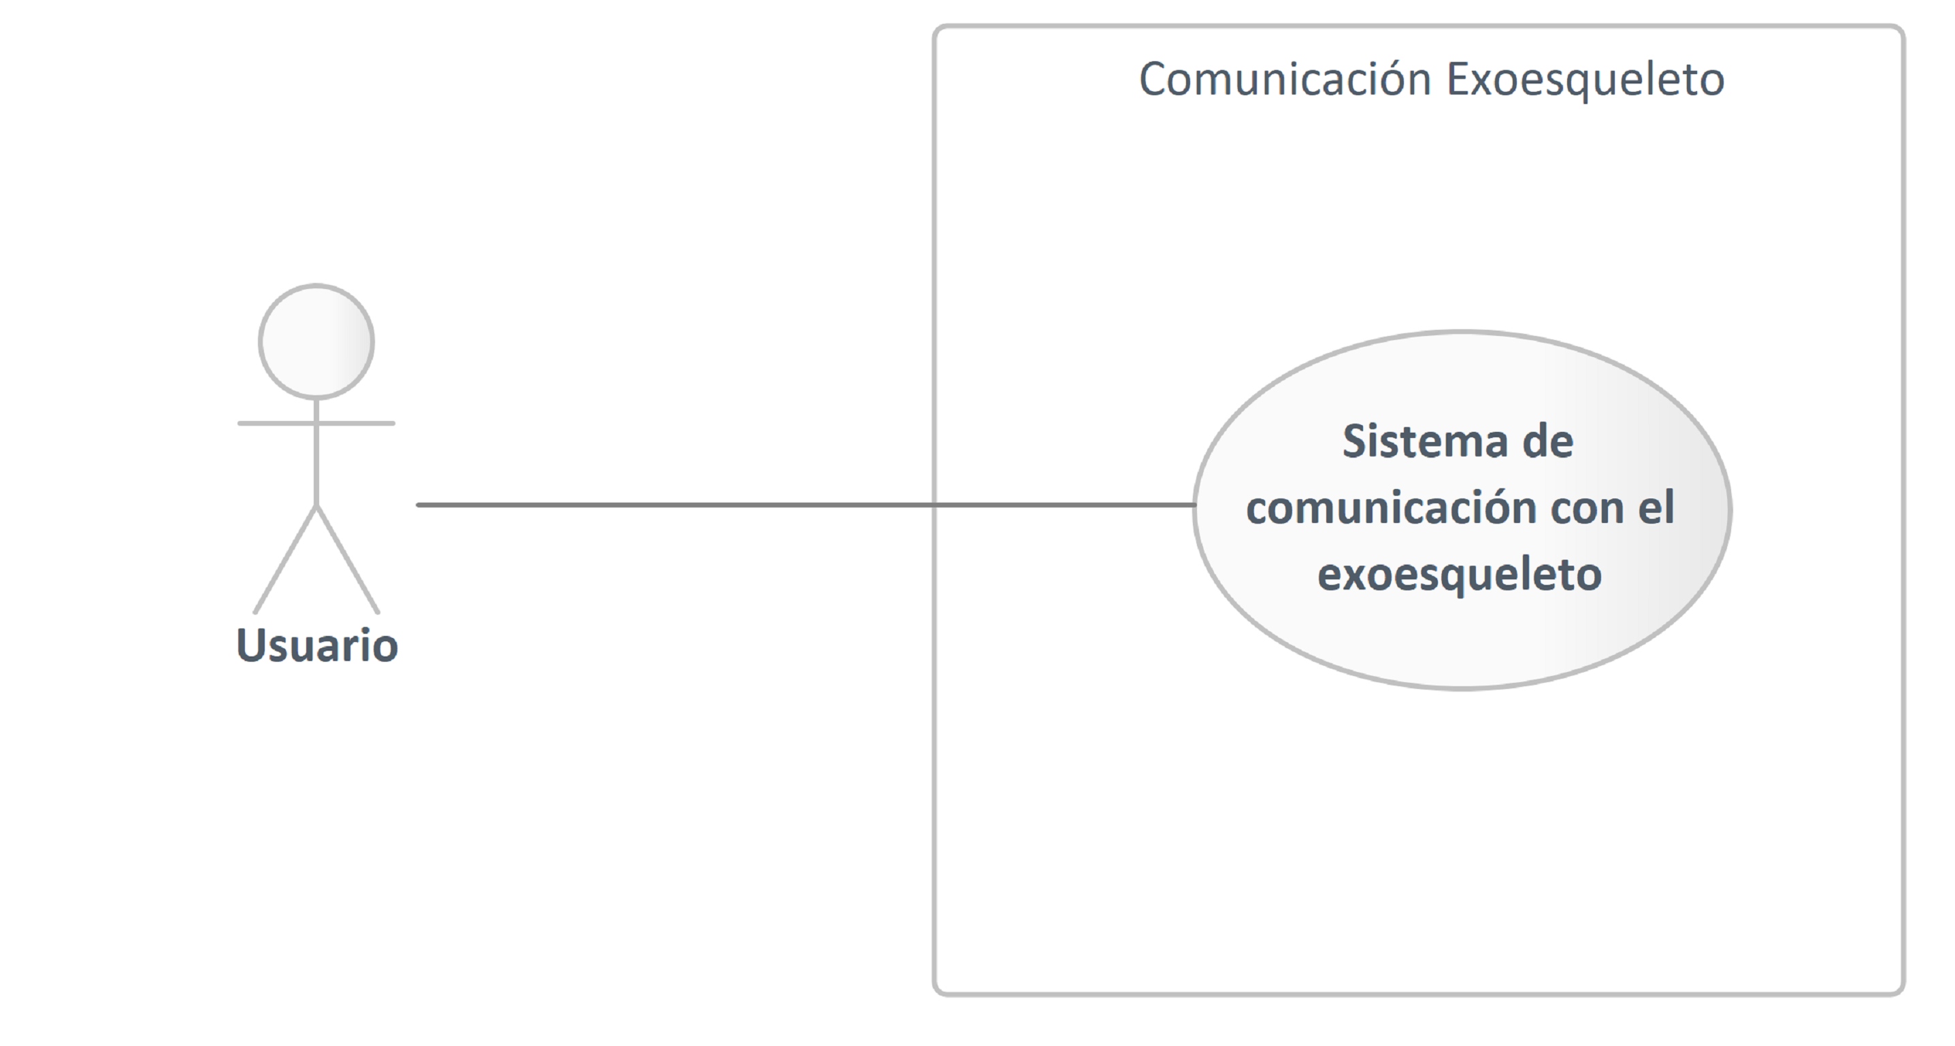

1. Use Case

### Comunicación Exoesqueleto

Boundary in package 'Use Case-Documentados y Sequencia'

Comunicación Exoesqueleto

Version 1.0 Phase 1.0 Proposed

carpi created on 25/4/2025. Last modified 25/4/2025

Extends

### Usuario

Actor in package 'Use Case-Documentados y Sequencia'

Usuario

Version 1.0 Phase 1.0 Proposed

carpi created on 25/4/2025. Last modified 25/4/2025

| ASSOCIATIONS | |
| --- | --- |
| Association (direction: Unspecified) | |
| Source: Public (Actor) Usuario | Target: Public (UseCase) 1.-Conexión / Desonexión con el exoesqueleto |
| Association (direction: Unspecified) | |
| Source: Public (Actor) Usuario | Target: Public (UseCase) 2.-Selección de rutinas |
| Association (direction: Unspecified) | |
| Source: Public (Actor) Usuario | Target: Public (UseCase) 3.-Selección de rutinas avanzadas |
| Association (direction: Unspecified) | |
| Source: Public (Actor) Usuario | Target: Public (UseCase) Sistema de comunicación con el exoesqueleto |

### Sistema de comunicación con el exoesqueleto

UseCase in package 'Use Case-Documentados y Sequencia'

Alcance: Comunicación con el exoesqueleto

Actor principal: Usuario

Sistema de comunicación con el exoesqueleto

Version 1.0 Phase 1.0 Proposed

carpi created on 25/4/2025. Last modified 28/4/2025

| ELEMENTS OWNED BY Sistema de comunicación con el exoesqueleto |
| --- |
| 1.-Conexión / Desonexión con el exoesqueleto : UseCase |
| 2.-Selección de rutinas : UseCase |
| 3.-Selección de rutinas avanzadas : UseCase |
| 4.-Selección por voz : UseCase |

| SCENARIOS |
| --- |
| Basic Path. Basic Path  El caso de uso principal comienza cuando el usuario abre la aplicación  1.-El usuario selecciona la opción de conectar exoesqueleto  2.-El usuario selecciona una rutina  3.-El usuario selecciona ir a las rutinas avanzadas  4.-El usuario selecciona una rutina avanzada  5.-El usuario selecciona regresar a las rutinas  6.-El usuario selecciona la opción de desconectar exoesqueleto. |
| Alternate. 1.-El usuario selecciona la opción de conectar exoesqueleto  1.-El exoesqueleto no se conecta  A.- Se muestra mensaje del fallo de comunicación  B.- El usuario verifica que el exoesqueleto este vinculado con el teléfono |
| Alternate. 2.-El usuario selecciona una rutina  1.-La rutina no se ve reflejada en el exoesqueleto  A.-El usuario verifica la conexión entre dispositivo y exoesqueleto  B.-El usuario vuelve a intentarlo |
| Alternate. 3.-El usuario selecciona ir a las rutinas avanzadas  1.-No se puede avanzar a la pantalla de rutinas avanzadas  A.-El usuario vuelve a intentarlo |
| Alternate. 4.-El usuario selecciona una rutina avanzada  1.-La rutina no se ve reflejada en el exoesqueleto  A.-El usuario verifica la conexión entre dispositivo y exoesqueleto  B.-El usuario vuelve a intentarlo |
| Alternate. 5.-El usuario selecciona regresar a las rutinas  1.-No se puede avanzar a la pantalla de rutinas  A.-El usuario vuelve a intentarlo |
| Alternate. 6.-El usuario selecciona la opción de desconectar exoesqueleto.  1.-El exoesqueleto no se desconecta  A.- Se muestra mensaje del fallo de comunicación  B.- El usuario verifica que el exoesqueleto este vinculado con el teléfono y en el rango específico |

| CONSTRAINTS |
| --- |
| Post-condition. Selección por voz  [ Approved, Weight is 0. ] |
| Post-condition. Selección de rutina avanzada  [ Approved, Weight is 0. ] |
| Post-condition. Selección de rutina  [ Approved, Weight is 0. ] |
| Post-condition. Conexión / desconexión del exoesqueleto  [ Approved, Weight is 0. ] |
| Pre-condition. Para seleccionar cualquier rutina el exoesqueleto debe haber sido conectado correctamente  [ Approved, Weight is 0. ] |

| ASSOCIATIONS | |
| --- | --- |
| Association (direction: Unspecified) | |
| Source: Public (Actor) Usuario | Target: Public (UseCase) Sistema de comunicación con el exoesqueleto |

#### Sistema de comunicación con el exoesqueleto diagram

Use Case diagram in package 'Use Case-Documentados y Sequencia'

Sistema de comunicación con el exoesqueleto

Version 1.0

carpi created on 25/4/2025. Last modified 25/4/2025

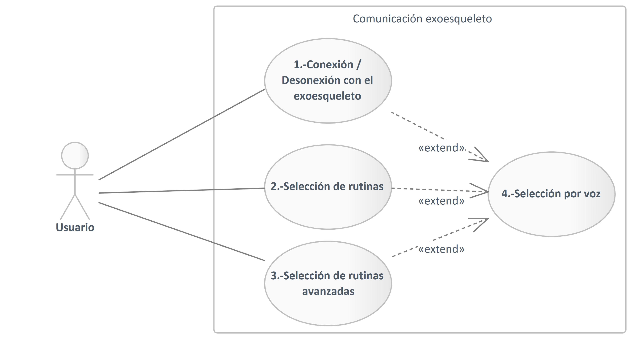

1. Sistema de comunicación con el exoesqueleto

#### 1.-Conexión / Desonexión con el exoesqueleto

UseCase owned by 'Sistema de comunicación con el exoesqueleto', in package 'Use Case-Documentados y Sequencia'

Alcance: Comunicación con el exoesqueleto

Actor principal: Usuario

1.-Conexión / Desonexión con el exoesqueleto

Version 1.0 Phase 1.0 Proposed

carpi created on 25/4/2025. Last modified 28/4/2025

| ELEMENTS OWNED BY 1.-Conexión / Desonexión con el exoesqueleto |
| --- |
| Comm_provider : Class |
| Exoesqueleto : Class |
| InicioPage : Class |
| Conexión / Desconexión con el exoesqueleto : Interaction |

| SCENARIOS |
| --- |
| Basic Path. Basic Path  El caso de uso comienza cuando el usuario abre la aplicación  1.-El usuario presiona el botón de conectar exoesqueleto  2.-El usuario visualiza la pantalla de rutinas.  3.-El usuario presiona el botón de apagar exoesqueleto |
| Alternate. 2.-El usuario visualiza la pantalla de rutinas.  1.-La pantalla no se visuliza correctamente  A.-El usuario reinicia la aplicación |
| Alternate. 1.-El usuario presiona el botón de conectar exoesqueleto  1.-El exoesqueleto no se conecta  A.- Se muestra mensaje del fallo de comunicación  B.- El usuario verifica que el exoesqueleto este vinculado con el teléfono |
| Alternate. 3.-El usuario presiona el botón de apagar exoesqueleto  1.-El exoesqueleto no se desconecta  A.- Se muestra mensaje del fallo de comunicación  B.- El usuario verifica que el exoesqueleto este vinculado con el teléfono |

| CONSTRAINTS |
| --- |
| Post-condition. Se ha terminado la conexión con el exoesqueleto  [ Approved, Weight is 0. ] |
| Post-condition. Se ha establecido la conexión con el exoesqueleto  [ Approved, Weight is 0. ] |
| Pre-condition. Para poder terminar la conexión con el exoesqueleto el usuario debe estar en la pantalla de rutinas  [ Approved, Weight is 0. ] |

| CONNECTORS |
| --- |
| Extend «extend» Source -> Destination  From: 1.-Conexión / Desonexión con el exoesqueleto : UseCase, Public  To: 4.-Selección por voz : UseCase, Public |

| ASSOCIATIONS | |
| --- | --- |
| Association (direction: Unspecified) | |
| Source: Public (Actor) Usuario | Target: Public (UseCase) 1.-Conexión / Desonexión con el exoesqueleto |

##### Comm_provider

Class owned by '1.-Conexión / Desonexión con el exoesqueleto', in package 'Use Case-Documentados y Sequencia'

Comm_provider

Version 1.0 Phase 1.0 Proposed

carpi created on 28/4/2025. Last modified 28/4/2025

| ASSOCIATIONS | |
| --- | --- |
| Association (direction: Source -> Destination) | |
| Source: Public (Class) InicioPage  Cardinality: [1] | Target: Public (Class) Comm_provider  Cardinality: [1] |

##### Exoesqueleto

Class owned by '1.-Conexión / Desonexión con el exoesqueleto', in package 'Use Case-Documentados y Sequencia'

Exoesqueleto

Version 1.0 Phase 1.0 Proposed

minec created on 28/4/2025. Last modified 28/4/2025

##### InicioPage

Class owned by '1.-Conexión / Desonexión con el exoesqueleto', in package 'Use Case-Documentados y Sequencia'

InicioPage

Version 1.0 Phase 1.0 Proposed

carpi created on 28/4/2025. Last modified 28/4/2025

| ASSOCIATIONS | |
| --- | --- |
| Association (direction: Source -> Destination) | |
| Source: Public (Class) InicioPage  Cardinality: [1] | Target: Public (Class) Comm_provider  Cardinality: [1] |

##### Conexión / Desconexión con el exoesqueleto

Interaction owned by '1.-Conexión / Desonexión con el exoesqueleto', in package 'Use Case-Documentados y Sequencia'

Conexión / Desconexión con el exoesqueleto

Version 1.0 Phase 1.0 Proposed

minec created on 28/4/2025. Last modified 28/4/2025

| ELEMENTS OWNED BY Conexión / Desconexión con el exoesqueleto |
| --- |
| PInicio : Sequence «boundary» |

###### Conexión / Desconexión con el exoesqueleto diagram

Interaction diagram in package 'Use Case-Documentados y Sequencia'

Conexión / Desconexión con el exoesqueleto

Version 1.0

minec created on 28/4/2025. Last modified 28/4/2025

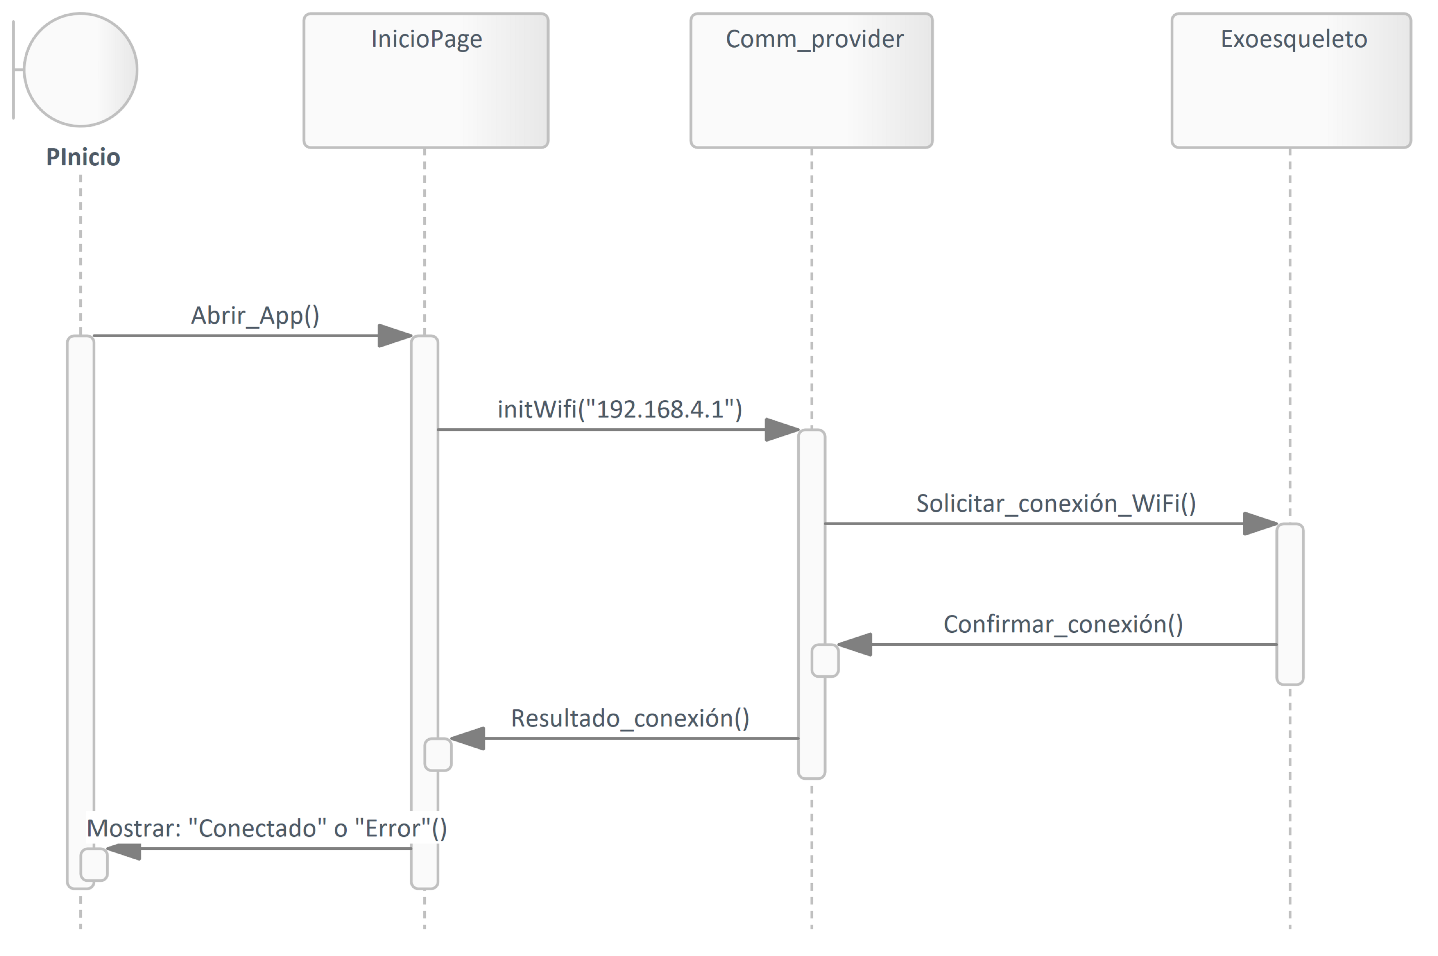

1. Conexión / Desconexión con el exoesqueleto

|  |
| --- |
| INTERACTION MESSAGES |
| 1.0 'Abrir_App' from 'PInicio' sent to 'InicioPage'.  Synchronous Call. Returns void.  [ Return is False. Iteration is False. New group is False. ] |
| 1.1 'initWifi("192.168.4.1")' from 'InicioPage' sent to 'Comm_provider'.  Synchronous Call. Returns void.  [ Return is False. Iteration is False. New group is False. ] |
| 1.2 'Solicitar_conexión_WiFi' from 'Comm_provider' sent to 'Exoesqueleto'.  Synchronous Call. Returns void.  [ Return is False. Iteration is False. New group is False. ] |
| 1.3 'Confirmar_conexión' from 'Exoesqueleto' sent to 'Comm_provider'.  Synchronous Call. Returns void.  [ Return is False. Iteration is False. New group is False. ] |
| 1.4 'Resultado_conexión' from 'Comm_provider' sent to 'InicioPage'.  Synchronous Call. Returns void.  [ Return is False. Iteration is False. New group is False. ] |
| 1.5 'Mostrar: "Conectado" o "Error"' from 'InicioPage' sent to 'PInicio'.  Synchronous Call. Returns void.  [ Return is False. Iteration is False. New group is False. ] |

###### PInicio

Sequence «boundary» owned by 'Conexión / Desconexión con el exoesqueleto', in package 'Use Case-Documentados y Sequencia'

PInicio

Version 1.0 Phase 1.0 Proposed

minec created on 28/4/2025. Last modified 28/4/2025

| OUTGOING BEHAVIORAL RELATIONSHIPS |
| --- |
| Name: Abrir_App  Sequence from «boundary» PInicio to InicioPage |

| INCOMING BEHAVIORAL RELATIONSHIPS |
| --- |
| Name: Mostrar: "Conectado" o "Error"  Sequence from InicioPage to «boundary» PInicio |

#### 2.-Selección de rutinas

UseCase owned by 'Sistema de comunicación con el exoesqueleto', in package 'Use Case-Documentados y Sequencia'

Alcance: Comunicación con el exoesqueleto

Actor principal: Usuario

2.-Selección de rutinas

Version 1.0 Phase 1.0 Proposed

carpi created on 25/4/2025. Last modified 28/4/2025

| ELEMENTS OWNED BY 2.-Selección de rutinas |
| --- |
| Exoesqueleto : Class |
| InicioPage : Class |
| Rutinas : Class |
| RutinasPage : Class |
| Selección de Rutinas : Interaction |

| SCENARIOS |
| --- |
| Basic Path. Basic Path  El caso de uso comienza cuando el usuario llega a la pantalla de rutinas  1.-El usuario selecciona una rutina  2.-El usuario ve reflejada la rutina en el exoesqueleto |
| Alternate. 1.-El usuario selecciona una rutina  1.-La rutina no se selecciona correctamente  A.-El usuario vuelve a intentarlo |
| Alternate. 2.-El usuario ve reflejada la rutina en el exoesqueleto  1.-La rutina no se ve reflejada en el exoesqueleto  A.-El usuario verifica la conexión entre dispositivo y exoesqueleto  B.-El usuario vuelve a intentarlo |

| CONSTRAINTS |
| --- |
| Post-condition. El exoesqueleto ha recibido la rutina a ejecutar  [ Approved, Weight is 0. ] |
| Pre-condition. Se debe haber establecido la conexión con el exoesqueleto  [ Approved, Weight is 0. ] |

| CONNECTORS |
| --- |
| Extend «extend» Source -> Destination  From: 2.-Selección de rutinas : UseCase, Public  To: 4.-Selección por voz : UseCase, Public |

| ASSOCIATIONS | |
| --- | --- |
| Association (direction: Unspecified) | |
| Source: Public (Actor) Usuario | Target: Public (UseCase) 2.-Selección de rutinas |

##### Exoesqueleto

Class owned by '2.-Selección de rutinas', in package 'Use Case-Documentados y Sequencia'

Exoesqueleto

Version 1.0 Phase 1.0 Proposed

minec created on 28/4/2025. Last modified 28/4/2025

##### InicioPage

Class owned by '2.-Selección de rutinas', in package 'Use Case-Documentados y Sequencia'

InicioPage

Version 1.0 Phase 1.0 Proposed

carpi created on 28/4/2025. Last modified 28/4/2025

| CONNECTORS |
| --- |
| Usage Source -> Destination  From: InicioPage : Class, Public  To: Rutinas : Class, Public |

| ASSOCIATIONS | |
| --- | --- |
| Association (direction: Source -> Destination) | |
| Source: Public (Class) InicioPage  Cardinality: [1] | Target: Public (Class) RutinasPage  Cardinality: [1] |

##### Rutinas

Class owned by '2.-Selección de rutinas', in package 'Use Case-Documentados y Sequencia'

Rutinas

Version 1.0 Phase 1.0 Proposed

carpi created on 28/4/2025. Last modified 28/4/2025

| CONNECTORS |
| --- |
| Usage Source -> Destination  From: RutinasPage : Class, Public  To: Rutinas : Class, Public |
| Usage Source -> Destination  From: InicioPage : Class, Public  To: Rutinas : Class, Public |

##### RutinasPage

Class owned by '2.-Selección de rutinas', in package 'Use Case-Documentados y Sequencia'

RutinasPage

Version 1.0 Phase 1.0 Proposed

carpi created on 28/4/2025. Last modified 28/4/2025

| CONNECTORS |
| --- |
| Usage Source -> Destination  From: RutinasPage : Class, Public  To: Rutinas : Class, Public |

| ASSOCIATIONS | |
| --- | --- |
| Association (direction: Source -> Destination) | |
| Source: Public (Class) InicioPage  Cardinality: [1] | Target: Public (Class) RutinasPage  Cardinality: [1] |

##### Selección de Rutinas

Interaction owned by '2.-Selección de rutinas', in package 'Use Case-Documentados y Sequencia'

Selección de Rutinas

Version 1.0 Phase 1.0 Proposed

minec created on 28/4/2025. Last modified 28/4/2025

| ELEMENTS OWNED BY Selección de Rutinas |
| --- |
| PRutinas : Sequence «boundary» |

###### Selección de Rutinas diagram

Interaction diagram in package 'Use Case-Documentados y Sequencia'

Selección de Rutinas

Version 1.0

minec created on 28/4/2025. Last modified 28/4/2025

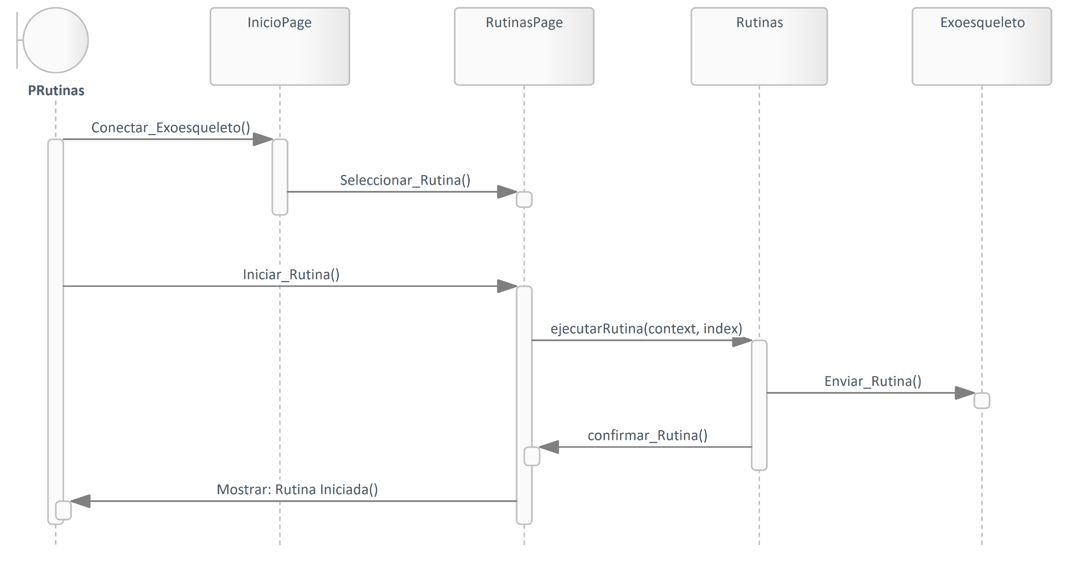

1. Selección de Rutinas

|  |
| --- |
| INTERACTION MESSAGES |
| 1.0 'Conectar_Exoesqueleto' from 'PRutinas' sent to 'InicioPage'.  Synchronous Call. Returns void.  [ Return is False. Iteration is False. New group is False. ] |
| 1.1 'Seleccionar_Rutina' from 'InicioPage' sent to 'RutinasPage'.  Synchronous Call. Returns void.  [ Return is False. Iteration is False. New group is False. ] |
| 1.2 'Iniciar_Rutina' from 'PRutinas' sent to 'RutinasPage'.  Synchronous Call. Returns void.  [ Return is False. Iteration is False. New group is False. ] |
| 1.3 'ejecutarRutina(context, index)' from 'RutinasPage' sent to 'Rutinas'.  Synchronous Call. Returns void.  [ Return is False. Iteration is False. New group is False. ] |
| 1.4 'Enviar_Rutina' from 'Rutinas' sent to 'Exoesqueleto'.  Synchronous Call. Returns void.  [ Return is False. Iteration is False. New group is False. ] |
| 1.5 'confirmar_Rutina' from 'Rutinas' sent to 'RutinasPage'.  Synchronous Call. Returns void.  [ Return is False. Iteration is False. New group is False. ] |
| 1.6 'Mostrar: Rutina Iniciada' from 'RutinasPage' sent to 'PRutinas'.  Synchronous Call. Returns void.  [ Return is False. Iteration is False. New group is False. ] |

###### PRutinas

Sequence «boundary» owned by 'Selección de Rutinas', in package 'Use Case-Documentados y Sequencia'

PRutinas

Version 1.0 Phase 1.0 Proposed

minec created on 28/4/2025. Last modified 28/4/2025

| OUTGOING BEHAVIORAL RELATIONSHIPS |
| --- |
| Name: Iniciar_Rutina  Sequence from «boundary» PRutinas to RutinasPage |
| Name: Conectar_Exoesqueleto  Sequence from «boundary» PRutinas to InicioPage |

| INCOMING BEHAVIORAL RELATIONSHIPS |
| --- |
| Name: Mostrar: Rutina Iniciada  Sequence from RutinasPage to «boundary» PRutinas |

#### 3.-Selección de rutinas avanzadas

UseCase owned by 'Sistema de comunicación con el exoesqueleto', in package 'Use Case-Documentados y Sequencia'

Alcance: Comunicación con el exoesqueleto

Actor principal: Usuario

3.-Selección de rutinas avanzadas

Version 1.0 Phase 1.0 Proposed

carpi created on 25/4/2025. Last modified 28/4/2025

| ELEMENTS OWNED BY 3.-Selección de rutinas avanzadas |
| --- |
| Exoesqueleto : Class |
| Rutinas : Class |
| RutinasAvanzadasPage : Class |
| RutinasPage : Class |
| Selección de rutinas avanzadas : Interaction |

| SCENARIOS |
| --- |
| Basic Path. Basic Path  El caso de uso comienza cuando el usuario selecciona la opción de rutinas avanzadas en la pantalla de rutinas.  1.-El usuario selecciona una rutina avanzada  2.-El usuario ve reflejada la rutina avanzada en el exoesqueleto |
| Alternate. 1.-El usuario selecciona una rutina avanzada  1.-La rutina no se ve reflejada en el exoesqueleto  A.-El usuario verifica la conexión entre dispositivo y exoesqueleto  B.-El usuario vuelve a intentarlo |
| Alternate. 2.-El usuario ve reflejada la rutina avanzada en el exoesqueleto  1.-La rutina no se ve reflejada en el exoesqueleto  A.-El usuario verifica la conexión entre dispositivo y exoesqueleto  B.-El usuario vuelve a intentarlo |

| CONNECTORS |
| --- |
| Extend «extend» Source -> Destination  From: 3.-Selección de rutinas avanzadas : UseCase, Public  To: 4.-Selección por voz : UseCase, Public |

| ASSOCIATIONS | |
| --- | --- |
| Association (direction: Unspecified) | |
| Source: Public (Actor) Usuario | Target: Public (UseCase) 3.-Selección de rutinas avanzadas |

##### Exoesqueleto

Class owned by '3.-Selección de rutinas avanzadas', in package 'Use Case-Documentados y Sequencia'

Exoesqueleto

Version 1.0 Phase 1.0 Proposed

minec created on 28/4/2025. Last modified 28/4/2025

##### Rutinas

Class owned by '3.-Selección de rutinas avanzadas', in package 'Use Case-Documentados y Sequencia'

Rutinas

Version 1.0 Phase 1.0 Proposed

carpi created on 28/4/2025. Last modified 28/4/2025

| CONNECTORS |
| --- |
| Usage Source -> Destination  From: RutinasAvanzadasPage : Class, Public  To: Rutinas : Class, Public |
| Usage Source -> Destination  From: RutinasPage : Class, Public  To: Rutinas : Class, Public |

##### RutinasAvanzadasPage

Class owned by '3.-Selección de rutinas avanzadas', in package 'Use Case-Documentados y Sequencia'

RutinasAvanzadasPage

Version 1.0 Phase 1.0 Proposed

carpi created on 28/4/2025. Last modified 28/4/2025

| CONNECTORS |
| --- |
| Usage Source -> Destination  From: RutinasAvanzadasPage : Class, Public  To: Rutinas : Class, Public |

| ASSOCIATIONS | |
| --- | --- |
| Association (direction: Source -> Destination) | |
| Source: Public (Class) RutinasPage  Cardinality: [1] | Target: Public (Class) RutinasAvanzadasPage  Cardinality: [1] |

##### RutinasPage

Class owned by '3.-Selección de rutinas avanzadas', in package 'Use Case-Documentados y Sequencia'

RutinasPage

Version 1.0 Phase 1.0 Proposed

carpi created on 28/4/2025. Last modified 28/4/2025

| CONNECTORS |
| --- |
| Usage Source -> Destination  From: RutinasPage : Class, Public  To: Rutinas : Class, Public |

| ASSOCIATIONS | |
| --- | --- |
| Association (direction: Source -> Destination) | |
| Source: Public (Class) RutinasPage  Cardinality: [1] | Target: Public (Class) RutinasAvanzadasPage  Cardinality: [1] |

##### Selección de rutinas avanzadas

Interaction owned by '3.-Selección de rutinas avanzadas', in package 'Use Case-Documentados y Sequencia'

Selección de rutinas avanzadas

Version 1.0 Phase 1.0 Proposed

minec created on 28/4/2025. Last modified 28/4/2025

| ELEMENTS OWNED BY Selección de rutinas avanzadas |
| --- |
| PRutinasAvanzadas : Sequence «boundary» |

###### Selección de rutinas avanzadas diagram

Interaction diagram in package 'Use Case-Documentados y Sequencia'

Selección de rutinas avanzadas

Version 1.0

minec created on 28/4/2025. Last modified 28/4/2025

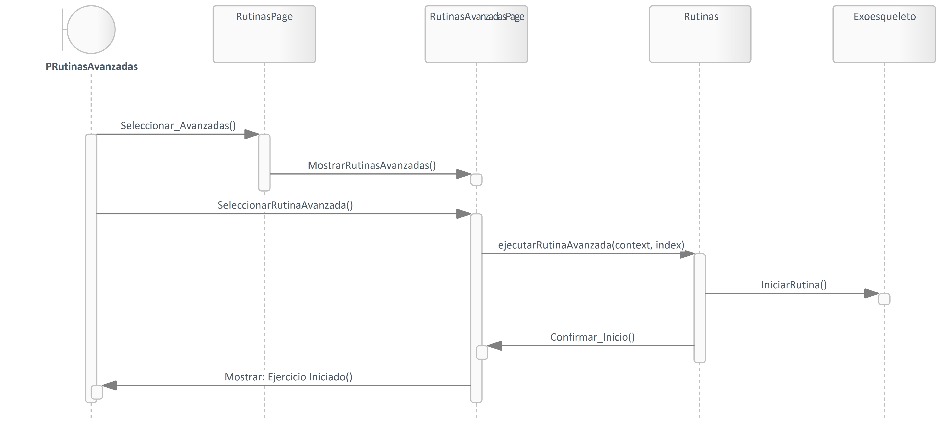

1. Selección de rutinas avanzadas

|  |
| --- |
| INTERACTION MESSAGES |
| 1.0 'Seleccionar_Avanzadas' from 'PRutinasAvanzadas' sent to 'RutinasPage'.  Synchronous Call. Returns void.  [ Return is False. Iteration is False. New group is False. ] |
| 1.1 'MostrarRutinasAvanzadas' from 'RutinasPage' sent to 'RutinasAvanzadasPage'.  Synchronous Call. Returns void.  [ Return is False. Iteration is False. New group is False. ] |
| 1.2 'SeleccionarRutinaAvanzada' from 'PRutinasAvanzadas' sent to 'RutinasAvanzadasPage'.  Synchronous Call. Returns void.  [ Return is False. Iteration is False. New group is False. ] |
| 1.3 'ejecutarRutinaAvanzada(context, index)' from 'RutinasAvanzadasPage' sent to 'Rutinas'.  Synchronous Call. Returns void.  [ Return is False. Iteration is False. New group is False. ] |
| 1.4 'IniciarRutina' from 'Rutinas' sent to 'Exoesqueleto'.  Synchronous Call. Returns void.  [ Return is False. Iteration is False. New group is False. ] |
| 1.5 'Confirmar_Inicio' from 'Rutinas' sent to 'RutinasAvanzadasPage'.  Synchronous Call. Returns void.  [ Return is False. Iteration is False. New group is False. ] |
| 1.6 'Mostrar: Ejercicio Iniciado' from 'RutinasAvanzadasPage' sent to 'PRutinasAvanzadas'.  Synchronous Call. Returns void.  [ Return is False. Iteration is False. New group is False. ] |

###### PRutinasAvanzadas

Sequence «boundary» owned by 'Selección de rutinas avanzadas', in package 'Use Case-Documentados y Sequencia'

PRutinasAvanzadas

Version 1.0 Phase 1.0 Proposed

minec created on 28/4/2025. Last modified 28/4/2025

| OUTGOING BEHAVIORAL RELATIONSHIPS |
| --- |
| Name: Seleccionar_Avanzadas  Sequence from «boundary» PRutinasAvanzadas to RutinasPage |
| Name: SeleccionarRutinaAvanzada  Sequence from «boundary» PRutinasAvanzadas to RutinasAvanzadasPage |

| INCOMING BEHAVIORAL RELATIONSHIPS |
| --- |
| Name: Mostrar: Ejercicio Iniciado  Sequence from RutinasAvanzadasPage to «boundary» PRutinasAvanzadas |

#### 4.-Selección por voz

UseCase owned by 'Sistema de comunicación con el exoesqueleto', in package 'Use Case-Documentados y Sequencia'

Alcance: Comunicación con el exoesqueleto

Actor principal: Usuario

4.-Selección por voz

Version 1.0 Phase 1.0 Proposed

carpi created on 25/4/2025. Last modified 28/4/2025

| ELEMENTS OWNED BY 4.-Selección por voz |
| --- |
| Usuario : Actor |
| Comandos_voz : Class |
| Exoesqueleto : Class |
| Rutinas : Class |
| RutinasAvanzadasPage : Class |
| RutinasPage : Class |
| Seleción por voz : Interaction |

| SCENARIOS |
| --- |
| Basic Path. Basic Path  El caso de uso comienza cuando el usuario dice en voz alta "iniciar"  1.-El usuario dice en voz alta "conectar" para conectarse al exoesqueleto  2.-El usuario dice en voz alta el comando de alguna rutina ("marcha", "equilibrio","piernas","avanzada")  3.-El usuario dice en voz alta el comando de alguna rutina avanzada ("uno", "dos","tres","cuatro")  4.-El usuario dice en voz alta el comando "regresar" desde la pantalla de rutinas avanzadas para regresar a la pantalla de rutinas  5.-El usuario dice en voz alta el comando "apagar" desde la pantalla de rutinas avanzadas para apagar la conexión con el exoesqueleto |
| Alternate. 1.-El usuario dice en voz alta "conectar" para conectarse al exoesqueleto  1.-El comando no se reconoce.  A.-El usuario vuelve a intentarlo con voz más alta y mejor dicción. |
| Alternate. 2.-El usuario dice en voz alta el comando de alguna rutina ("marcha", "equilibrio","piernas","avanzada")  1.-El comando no se reconoce.  A.-El usuario vuelve a intentarlo con voz más alta y mejor dicción.  2.-La rutina no se selecciona correctamente  A.-El usuario vuelve a intentarlo  3.-La rutina no se ve reflejada en el exoesqueleto  A.-El usuario verifica la conexión entre dispositivo y exoesqueleto  B.-El usuario vuelve a intentarlo |
| Alternate. 3.-El usuario dice en voz alta el comando de alguna rutina avanzada ("uno", "dos","tres","cuatro")  1.-El comando no se reconoce.  A.-El usuario vuelve a intentarlo con voz más alta y mejor dicción.  2.-La rutina avanzada no se selecciona correctamente  A.-El usuario vuelve a intentarlo  3.-La rutina avanzada no se ve reflejada en el exoesqueleto  A.-El usuario verifica la conexión entre dispositivo y exoesqueleto  B.-El usuario vuelve a intentarlo |
| Alternate. 4.-El usuario dice en voz alta el comando "regresar" desde la pantalla de rutinas avanzadas para regresar a la pantalla de rutinas  1.-El comando no se reconoce.  A.-El usuario vuelve a intentarlo con voz más alta y mejor dicción. |
| Alternate. 5.-El usuario dice en voz alta el comando "apagar" desde la pantalla de rutinas avanzadas para apagar la conexión con el exoesqueleto  1.-El comando no se reconoce.  A.-El usuario vuelve a intentarlo con voz más alta y mejor dicción. |

| CONSTRAINTS |
| --- |
| Post-condition. Selección de rutinas avanzadas  [ Approved, Weight is 0. ] |
| Post-condition. Selección de rutinas  [ Approved, Weight is 0. ] |
| Post-condition. Conexión / desconexión del exoesqueleto  [ Approved, Weight is 0. ] |
| Pre-condition. El usuario debe decir el comando de inicio  [ Approved, Weight is 0. ] |

| CONNECTORS |
| --- |
| Extend «extend» Source -> Destination  From: 3.-Selección de rutinas avanzadas : UseCase, Public  To: 4.-Selección por voz : UseCase, Public |
| Extend «extend» Source -> Destination  From: 1.-Conexión / Desonexión con el exoesqueleto : UseCase, Public  To: 4.-Selección por voz : UseCase, Public |
| Extend «extend» Source -> Destination  From: 2.-Selección de rutinas : UseCase, Public  To: 4.-Selección por voz : UseCase, Public |

##### Usuario

Actor owned by '4.-Selección por voz', in package 'Use Case-Documentados y Sequencia'

Usuario

Version 1.0 Phase 1.0 Proposed

carpi created on 28/4/2025. Last modified 28/4/2025

| OUTGOING BEHAVIORAL RELATIONSHIPS |
| --- |
| Name: Decir "iniciar marcha" o "iniciar ejercicio avanzado"  Sequence from Usuario to Comandos_voz |

##### Comandos_voz

Class owned by '4.-Selección por voz', in package 'Use Case-Documentados y Sequencia'

Comandos_voz

Version 1.0 Phase 1.0 Proposed

carpi created on 28/4/2025. Last modified 28/4/2025

| OUTGOING STRUCTURAL RELATIONSHIPS |
| --- |
| Aggregation from Comandos_voz to RutinasAvanzadasPage  [ Direction is 'Source -> Destination'. ] |
| Aggregation from Comandos_voz to RutinasPage  [ Direction is 'Source -> Destination'. ] |

| CONNECTORS |
| --- |
| Usage Source -> Destination  From: Comandos_voz : Class, Public  To: Rutinas : Class, Public |

##### Exoesqueleto

Class owned by '4.-Selección por voz', in package 'Use Case-Documentados y Sequencia'

Exoesqueleto

Version 1.0 Phase 1.0 Proposed

minec created on 28/4/2025. Last modified 28/4/2025

##### Rutinas

Class owned by '4.-Selección por voz', in package 'Use Case-Documentados y Sequencia'

Rutinas

Version 1.0 Phase 1.0 Proposed

carpi created on 28/4/2025. Last modified 28/4/2025

| CONNECTORS |
| --- |
| Usage Source -> Destination  From: RutinasPage : Class, Public  To: Rutinas : Class, Public |
| Usage Source -> Destination  From: RutinasAvanzadasPage : Class, Public  To: Rutinas : Class, Public |
| Usage Source -> Destination  From: Comandos_voz : Class, Public  To: Rutinas : Class, Public |

##### RutinasAvanzadasPage

Class owned by '4.-Selección por voz', in package 'Use Case-Documentados y Sequencia'

RutinasAvanzadasPage

Version 1.0 Phase 1.0 Proposed

carpi created on 28/4/2025. Last modified 28/4/2025

| INCOMING STRUCTURAL RELATIONSHIPS |
| --- |
| Aggregation from Comandos_voz to RutinasAvanzadasPage  [ Direction is 'Source -> Destination'. ] |

| CONNECTORS |
| --- |
| Usage Source -> Destination  From: RutinasAvanzadasPage : Class, Public  To: Rutinas : Class, Public |

| ASSOCIATIONS | |
| --- | --- |
| Association (direction: Source -> Destination) | |
| Source: Public (Class) RutinasPage  Cardinality: [1] | Target: Public (Class) RutinasAvanzadasPage  Cardinality: [1] |

##### RutinasPage

Class owned by '4.-Selección por voz', in package 'Use Case-Documentados y Sequencia'

RutinasPage

Version 1.0 Phase 1.0 Proposed

carpi created on 28/4/2025. Last modified 28/4/2025

| INCOMING STRUCTURAL RELATIONSHIPS |
| --- |
| Aggregation from Comandos_voz to RutinasPage  [ Direction is 'Source -> Destination'. ] |

| CONNECTORS |
| --- |
| Usage Source -> Destination  From: RutinasPage : Class, Public  To: Rutinas : Class, Public |

| ASSOCIATIONS | |
| --- | --- |
| Association (direction: Source -> Destination) | |
| Source: Public (Class) RutinasPage  Cardinality: [1] | Target: Public (Class) RutinasAvanzadasPage  Cardinality: [1] |

##### Seleción por voz

Interaction owned by '4.-Selección por voz', in package 'Use Case-Documentados y Sequencia'

Seleción por voz

Version 1.0 Phase 1.0 Proposed

minec created on 28/4/2025. Last modified 28/4/2025

| ELEMENTS OWNED BY Seleción por voz |
| --- |
| PInicio : Sequence «boundary» |
| PRutinasAvanzadas : Sequence «boundary» |

###### Seleción por voz diagram

Interaction diagram in package 'Use Case-Documentados y Sequencia'

Seleción por voz

Version 1.0

minec created on 28/4/2025. Last modified 28/4/2025

1. Seleción por voz

|  |
| --- |
| INTERACTION MESSAGES |
| 1.0 'Decir "iniciar marcha" o "iniciar ejercicio avanzado"' from 'Usuario' sent to 'Comandos_voz'.  Synchronous Call. Returns void.  [ Return is False. Iteration is False. New group is False. ] |
| 1.1 'DetectarComando' from 'Comandos_voz' sent to 'RutinasPage'.  Synchronous Call. Returns void.  [ Return is False. Iteration is False. New group is False. ] |
| 1.2 'DetectarComando' from 'Comandos_voz' sent to 'RutinasAvanzadasPage'.  Synchronous Call. Returns void.  [ Return is False. Iteration is False. New group is False. ] |
| 1.3 'ejecutarRutina(context, index' from 'RutinasPage' sent to 'Rutinas'.  Synchronous Call. Returns void.  [ Return is False. Iteration is False. New group is False. ] |
| 1.4 'confirmarEjecucion' from 'Rutinas' sent to 'Exoesqueleto'.  Synchronous Call. Returns void.  [ Return is False. Iteration is False. New group is False. ] |
| 1.5 'ConfirmarRutina' from 'Rutinas' sent to 'RutinasPage'.  Synchronous Call. Returns void.  [ Return is False. Iteration is False. New group is False. ] |
| 1.6 'ejecutarRutina(context, index' from 'RutinasAvanzadasPage' sent to 'Rutinas'.  Synchronous Call. Returns void.  [ Return is False. Iteration is False. New group is False. ] |
| 1.7 'confirmarEjecucion' from 'Rutinas' sent to 'Exoesqueleto'.  Synchronous Call. Returns void.  [ Return is False. Iteration is False. New group is False. ] |
| 1.8 'ConfirmarRutina' from 'Rutinas' sent to 'RutinasPage'.  Synchronous Call. Returns void.  [ Return is False. Iteration is False. New group is False. ] |
| 1.9 'mostrar: Feedback Rutina Iniciada' from 'RutinasPage' sent to 'PInicio'.  Synchronous Call. Returns void.  [ Return is False. Iteration is False. New group is False. ] |

###### PInicio

Sequence «boundary» owned by 'Seleción por voz', in package 'Use Case-Documentados y Sequencia'

PInicio

Version 1.0 Phase 1.0 Proposed

minec created on 28/4/2025. Last modified 28/4/2025

| INCOMING BEHAVIORAL RELATIONSHIPS |
| --- |
| Name: mostrar: Feedback Rutina Iniciada  Sequence from RutinasPage to «boundary» PInicio |

###### PRutinasAvanzadas

Sequence «boundary» owned by 'Seleción por voz', in package 'Use Case-Documentados y Sequencia'

PRutinasAvanzadas

Version 1.0 Phase 1.0 Proposed

minec created on 28/4/2025. Last modified 28/4/2025